
IP Communications Applications for Business Advantage

Metreos Communications Environment 2.1
Application Suite Administrator Guide

Copyright © 2005 Metreos Corporation
All Rights Reserved

Proprietary and Confidential Information
For Release under NDA Only

www.metreos.com | Part Number M-2400-AS-02
 | 8/2005

Information in this document is subject to change without notice.

Copyright © 2005 Metreos Corporation. All rights reserved. Metreos trademarks marked with a ® or © herein are registered or protected trademarks of Metreos in the U.S. and foreign countries. All other trademarks in the document are the property of their respective owners.

Table of Contents
Table of Contents 3
Preface 5
Intended Audience 5
Information This Book Contains 5
Style and Formatting Conventions 5
License/Certification Information 7
1. The Metreos Application Suite 12
Metreos ActiveRelay 12
Metreos ClickToTalk 12
Metreos Intercom 12
Metreos RapidRecord 12
Metreos ScheduledConference 13
Metreos VoiceTunnel 13
2. The Metreos Application Suite Administrator 14
3. Metreos Application Suite Management Interface 16
System Management 16
Change Administrator Password 17
RapidRecord 17
ScheduledConference 17
SMTP Server 17
System 17
Account Management 19
Create User 20
Edit Account 22
Devices 23
External Numbers 25
Remote Agent 26
Settings & Records Backup 26
Settings & Records Restore 28
4. Application Suite Reports 30
Account Summaries 31
Call Statistics Reports 32
Security and Access Control Reports 33
5. Application Configuration 34
Setting the Trigger Parameter for Metreos Applications 34
Metreos ActiveRelay Configuration 38
Installing the Cisco IP Phone Service 38
Configuring Metreos ActiveRelay 39
Adding a User to Active Relay 44
Metreos ClickToTalk Configuration 48
Metreos Intercom Configuration 53
Installing the Cisco IP Phone Service 53
Creating Intercom Groups 53
Configuring Metreos Intercom 57
Metreos RapidRecord Configuration 59
Configuring Metreos RapidRecord 60
Metreos ScheduledConference Configuration 63
Metreos VoiceTunnel Configuration 66
Appendix A: Cisco CallManager Configuration 72
Common Procedures 72
Global Metreos User Setup 72
Partitions 72
Calling Search Spaces 72
Calling Search Space Setup 73
Adding Cisco IP Phone Devices 73
Cisco IP Phone Services Setup 74
Creating CallManager Clusters 74
H.323 configuration 74
H.323 Gateway Setup 75
H.323 Device Setup 75
Route Patterns for Recording 76
Other Route Patterns 77
JTAPI configuration 77
CTI Route Point Setup 77
Associate the CTI Route Points with the metreos User 78
Adding lines to the CTI Route Points 78

Preface
This book explains how to deploy and configure the Metreos Application Suite to the Metreos Communications Environment (MCE). This book also describes each application in the suite and how each application is used.

Intended Audience
This book is intended for administrators who are planning to manage the MCE using the Metreos Management Console and the Metreos Application Suite using the Metreos Application Suite Administrative Console.

Information This Book Contains
The MCE Developer Guide is organized into the following Chapters:

- Chapter 1 The Metreos Application Suite – A brief overview the Metreos Application Suite
- Chapter 2 Metreos VoiceTunnel™ allows a remote user to connect to any enterprise IP communications system and place calls as if they were local to the system. With Metreos VoiceTunnel you can – An introduction to the Application Suite administrative console
- Chapter 3 Metreos Application Suite Management Interface – Procedures for configuring the Metreos Application Suite
- Chapter 4 Application Suite Reports – Procedures for configuring and using application suite reports
- Chapter 5 Application Configuration – Procedures for configuring each Metreos application
- Appendix A: Cisco CallManager – Procedures for setting up Cisco CallManager for the Metreos Application Suite

Style and Formatting Conventions
The following typographical components are used for defining special terms and command syntax:

Convention | Description
Bold typeface | Represents literal information such as  - Information and controls displayed on screen, including menu options, windows dialogs and field names  - Commands, file names, and directories  - In-line programming elements, such as class names and XML elements when referenced in the main text
Italic typeface | Italics typeface is used to denote  - A new concept  - A variable element such as filename.mca. In this example, filename represents the name of the file and .mca is the extension.  - A reference to a chapter or a section heading
Sans serif typeface | Denotes code or code fragments
… (ellipsis) | Denotes omitted content in code fragments
UPPERCASE | Denotes keys and keystroke combinations such as CTRL+ALT+DEL.

License/Certification Information

Metreos Corporation

End User License

Important – Use of this Software is subject to license restrictions.
Carefully read this license agreement before using the software.

This End User License Agreement (the “Agreement”) is a legal agreement between you, either individually or as an authorized representative of the company or organization acquiring the license, and Metreos Corporation (“Metreos”). USE OF SOFTWARE INDICATES YOUR COMPLETE AND UNCONDITIONAL ACCEPTANCE OF THE TERMS AND CONDITIONS SET FORTH IN THIS AGREEMENT. If you do not agree to these terms and conditions, promptly return or, if electronically received, certify destruction of the Software and all accompanying items within five days after receipt of Software and you will receive a full refund of the applicable license fees paid.

1. License Grant

a. The software programs you are installing, downloading, or have acquired with this Agreement, including any related equipment or hardware, documentation, updates, upgrades, modifications, revisions, copies and design data (“Software”) are copyrighted, trade secret and confidential information of Metreos and its licensors who maintain exclusive title to all Software and retain all rights not expressly granted by this Agreement. Metreos grants to you, subject to payment of appropriate license fees, a non-exclusive, non-transferable, internal-use only, term license to use the Software owned or distributed by Metreos in machine readable, object-code form on the computer hardware or at the site(s) for which an applicable license fee has been paid, as authorized by Metreos.

b. To the extent that you design applications that operate on the Metreos Communications Environment (the “MCE”), Metreos grants you a non-exclusive, non-transferable, internal-use only, term license to use the Software, including the MCE, for the purposes of operating such programs, subject to payment of appropriate license fees.

c. The license granted herein is contingent on your (or your organization’s) continued acceptance and subscription to the maintenance and support terms provided by Metreos. Termination by you or your organization of ongoing maintenance and support requirements terminates the license granted herein.

2. Restrictions and Intellectual Property Ownership

a. You may not (i) remove or modify any notice of Metreos’ proprietary rights, (ii) re-license, rent, lease, timeshare, or act as a service bureau or provide subscription services for the Software, (iii) use the Software to provide third-party training, except for training agents and contractors authorized under this Agreement; (iv) assign this Agreement or give the Software or an interest in the Software to another individual or entity; (v) cause or permit reverse engineering or decompilation of the Software; (vi) disclose results of any Software benchwork tests without Metreos’ prior written consent; or (vii) modify the Software or any portions thereof without Metreos’ prior written consent.

b. The Software, which is copyrighted, and any modifications, upgrades, or updates thereto, is the sole and exclusive property of Metreos and is a valuable asset and trade secret of Metreos. Metreos retains all ownership and intellectual property rights to the Software and to any modifications, upgrades, or updates thereto. Except for the rights granted in herein above, you shall have no right, title, or interest of any kind in or to the Software.

c. Metreos may audit your use of the Software. If Metreos gives you or your organization reasonable advance written notice, you agree to cooperate with the audit, and to provide reasonable assistance and access to information. You agree to immediately remit any underpaid license and technical support fees determined as the result of such audit.

3. Term and Termination.

a. This Agreement remains effective until expiration or termination. This Agreement will immediately terminate upon notice if you exceed the scope of the license granted or otherwise fail to comply with the provisions in sections 1 and 2 above. For any other material breach of the Agreement, Metreos may terminate this Agreement if you are in breach and fail to cure the breach within thirty (30) days of written notification. If Software is provided for a limited term use, this Agreement will automatically expire at the end of the authorized term.

b. Upon termination of this Agreement for any reason, you shall within ten (10) business days return to Metreos all Software. Additionally, you agree to delete from any permanent machine storage (i.e., hard disk) previously loaded copies of the Software in all forms. Upon request of Metreos, you shall certify in writing that all copies of the Software and associated documentation have been destroyed or returned to Metreos. The indemnity and limitation of liability obligations hereunder, as well as your obligations with respect to confidential treatment of the Software and Metreos’ trade secrets, other intellectual property, and proprietary information, shall survive the termination of this Agreement.

4. Limited Warranty.

a. Metreos warrants that the Software will substantially operate as described in the applicable Software documentation for ninety (90) days after Metreos delivers it to you. THE WARRANTY HEREIN IS EXCLUSIVE AND IN LIEU OF ALL OTHER WARRANTIES, WHETHER EXPRESS OR IMPLIED, INCLUDING THE IMPLIED WARRANTIES OF MERCHANTABILITY AND FITNESS FOR A PARTICULAR PURPOSE. METREOS MAKES NO WARRANTY THAT ANY SOFTWARE WILL PERFORM ERROR-FREE OR UNINTERRUPTED, OR THAT ALL ERRORS THEREIN CAN OR WILL BE CORRECTED. METREOS FURTHER DISCLAIMS ANY IMPLIED WARRANTIES ARISING FROM COURSE OF PERFORMANCE, COURSE OF DEALING OR USAGE OF TRADE.

b. For any breach of the above warranty, Metreos’ entire liability and your exclusive remedy shall be, at Metreos’ option, either (1) refund of the fees paid upon return of the Software to Metreos, or (2) correction or replacement of the Software that does not meet this limited warranty, provided you have complied with the terms of this Agreement.

5. Indemnity

a. Metreos will defend and indemnify you against a claim that any Software, infringes a patent or copyright, provided that: (i) you notify Metreos in writing within thirty (30) days of the claim; (ii) Metreos has sole control of the defense and all related settlement negotiations; and (iii) you provide Metreos with the assistance, information, and authority reasonably necessary to perform the above; reasonable out-of-pocket expenses incurred by you in providing such assistance will be reimbursed by Metreos.
b. Metreos shall have no liability for any claim of infringement resulting from: (i) your use of a superseded or altered release of the Software if infringement would have been avoided by the use of a subsequent unaltered release of the Software which Metreos provides to you; or (ii) any information, design, specification, instruction, software, data, or material not furnished by Metreos or (iii) any combination of the Software with other hardware, software or processes that, but for the combination, the Software would not be infringing.
c. In the event that some or all of the Software is held or is believed by Metreos to infringe, Metreos shall have the option, at its expense: (i) to modify the Software to be non-infringing; or (ii) to obtain for you a license to continue using the Software. If it is not commercially feasible to perform either of the above options, then Metreos may require from you return of the infringing Software and all rights thereto. Upon return of the infringing Software to Metreos, you may terminate the Agreement with ten (10) days’ written notice and you shall be entitled to a pro-rata refund of the fees paid for the infringing Software. This subsection sets forth Metreos’ entire liability and exclusive remedy for infringement.
d. You will defend and indemnify Metreos and its licensors against any claim incurred by, borne by or asserted against Metreos or its licensors that relates to or results from (i) your use of the Software, (ii) any intentional or willful conduct or negligence by you or (iii) any breach of an applicable representation, covenant or warranty contained herein.
e. Should the party seeking indemnification (“Indemnitee”) reasonably determine that the party from whom indemnity is sought (“Indemnitor”) has failed to assume the defense of any claim referenced herein, Indemnitee shall have the right to assume such defense and have all expense and cost of the defense reimbursed by Indemnitor, including reasonable attorneys fees.

6. Confidentiality

The Software contains proprietary and confidential information of Metreos as well as trade secrets owned by Metreos. You agree to hold the Software in strict confidence and not to disclose the Software in any way except as expressly permitted hereunder. You agree to protect the Software at least to the same extent that you protect your similar confidential information, but in no event less than reasonable care. You further agree that you will not, directly or indirectly, copy the structure, sequence, or organization of the Software, nor will you copy any portion of the Software or related documentation to produce software programs that are substantially similar to the Software.

7. LIMITATION OF LIABILITY

EXCEPT WHERE THIS EXCLUSION OR RESTRICTION OF LIABILITY WOULD BE VOID OR INEFFECTIVE UNDER APPLICABLE LAW, IN NO EVENT WILL METREOS BE LIABLE FOR ANY INDIRECT, INCIDENTAL, SPECIAL, OR CONSEQUENTIAL DAMAGES, OR DAMAGES FOR LOSS OF PROFITS, REVENUE, DATA, OR USE, INCURRED BY YOU OR ANY THIRD PARTY, WHETHER IN AN ACTION IN CONTRACT OR TORT, EVEN IF METREOS OR ANY OTHER PERSON HAS BEEN ADVISED OF THE POSSIBILITY OF SUCH DAMAGES. METREOS’ LIABILITY FOR DAMAGES HEREUNDER SHALL IN NO EVENT EXCEED THE AMOUNT OF FEES PAID BY YOU FOR THE SOFTWARE OR SERVICE GIVING RISE TO THE CLAIM. IN THE CASE WHERE NO AMOUNT WAS PAID, METREOS SHALL HAVE NO LIABILITY FOR ANY DAMAGES WHATSOEVER.

8. Assignment; Jurisdiction.

This Agreement will be binding upon, and will inure to the benefit of, the permitted successors and assigns of each party hereto. You may not assign, delegate, transfer, or otherwise convey this Agreement, or any of its rights hereunder, to any entity without the prior written consent of Metreos, and any attempted assignment or delegation without such consent shall be void. This Agreement, and all matters arising out of or relating to this Agreement, shall be governed by the laws of the State of Texas, United States of America. Any legal action or proceeding relating to this Agreement shall be instituted in any state or federal court in Travis or Dallas County, Texas, United States of America. Metreos and you agree to submit to the jurisdiction of, and agree that venue is proper in, the aforesaid courts in any such legal action or proceeding.

9. Severability; Waiver

In the event any provision of this Agreement is held to be invalid or unenforceable, the remaining provisions of this Agreement will remain in full force. The waiver by either party of any default or breach of this Agreement shall not constitute a waiver of any other or subsequent default or breach. Except for actions for nonpayment or breach of either party’s intellectual property rights, no action, regardless of form, arising out of this Agreement may be brought by either party more than two years after the cause of action has accrued. The headings appearing in this Agreement are inserted for convenience only, and will not be used to define, limit or enlarge the scope of this Agreement or any of the obligations herein.

10. Restricted Rights Notice.

The Software is commercial in nature and developed solely at private expense. The Software is delivered as "Commercial Computer Software" as defined in DFARS 252.227-7014 (June 1995) or as a commercial item as defined in FAR 2.101(a) and as provided with only such rights as are provided in this Agreement, which is Metreos’ standard commercial license for the Software. Technical data is provided with limited rights only as provided in DFAR 252.227-7015 (Nov. 1995) or FAR 52.227-14 (June 1987), whichever is applicable.

11. Payment; Interpretation; Compliance.

You will pay all amounts invoiced, in the currency specified on the invoice, within 30 days from the date of such invoice. This Agreement constitutes the complete agreement between the Parties and supersedes all previous and contemporaneous agreements, proposals, or representations, written or oral, concerning the subject matter of this Agreement. This Agreement may not be modified or amended except in a writing signed by a you and Metreos; no other act, document, usage, or custom shall be deemed to amend or modify this Agreement. It is expressly agreed that the terms and conditions of this Agreement supersede the terms of any purchase order. Each party agrees to comply with all relevant export laws and regulations of the United States and the country or territory in which the Services are provided (“Export Laws”) to assure that neither any deliverable, if any, nor any direct product thereof is (a) exported, directly or indirectly, in violation of Export Laws or (b) intended to be used for any purposes prohibited by the Export Laws, including without limitation nuclear, chemical, or biological weapons proliferation. Each party agrees to comply with all federal, state and local laws and regulations applicable to this Agreement. Each party represents and warrants that it is qualified to do business in the geographies in which it will perform its obligations under this Agreement, and will obtain all necessary licenses and permits, and satisfy any other legal, regulatory and administrative requirements, necessary to its performance hereunder.

The Metreos Application Suite
The Metreos Application Suite™ is a collection of voice over IP applications for the enterprise. Each application in the suite is a complete IP telephony application, ready to deploy and run at your site. The applications are built using Metreos tools and the applications execute within the Metreos Application Runtime Environment. Because the applications are built using Metreos tools, each application is easily and quickly customizable by your staff or integrator if the need arises.

The following sections summarize the Metreos Application Suite IP telephony applications.

Metreos ActiveRelay
Metreos ActiveRelay™ lets you receive calls at a single number, regardless of your physical location. It can, for example, bridge your cellular telephone to your office telephone and simultaneously ring both phones, allowing you to answer either phone.

Once connected, you can easily transfer the call to other devices that are configured with ActiveRelay. The call also does not exhibit multiple ring sequences as do older style call forwarding applications.

Metreos ClickToTalk
Metreos ClickToTalk™ is a speed dialing application allowing calls to any party in a contact list with a single click. Metreos ClickToTalk can be used by anyone in a Cisco CallManager group using a Cisco 7940, 7960, or 7970 IP telephone.

A ClickToTalk user can call a Microsoft Outlook contact by highlighting a contact and clicking a button on the Outlook toolbar. ClickToTalk then dials the selected contact from the user’s IP phone. Conferencing and recording of calls are also supported. Recorded calls can be sent by e-mail to all call participants.

Metreos Intercom
Metreos Intercom™ permits instant communication over IP phones without the need to dial a number. Users select from a contact group on the IP phone display, and audio connectivity is established.

Metreos Intercom can also be configured to act as a group paging system for broadcasting voice messages or pages in a fashion similar to a traditional paging system. Using the TalkBack feature, an intercom listener can press the Reply button and instantly conference with each party in the intercom group.

Metreos RapidRecord
Metreos RapidRecord™ automatically records calls placed to and from a configured group of devices, permitting seamless, hands-off call recording. Recorded calls can be played back either from a Web interface, or directly from the IP phone that placed or received the call.

Metreos ScheduledConference
Metreos ScheduledConference™ is a Web-scheduled dial-in and dial-out conferencing system. Conferences can be scheduled from an easy-to-use Web interface, eliminating any need for operator or administrative assistance. Features include the adding of conference parties, party mute and unmute, and removal of participants from conference.

Metreos VoiceTunnel
Metreos VoiceTunnel™ allows a remote user to connect to any enterprise IP communications system and place calls as if they were local to the system. With Metreos VoiceTunnel you can

- Place all calls locally, avoiding international and long-distance toll charges
- Authenticate call usage and apply a broad range of policies to the billing and accounting of communications costs
- Manage, monitor, and report on the use of the communications system

The Metreos Application Suite Administrator
Communications system administrators manage the Metreos Application Suite using the Metreos Application Suite Administrator. The Administrator console includes configuration facilities of applications in the suite, and provides easy access to a comprehensive set of reporting and accounting functions.

Navigate to the administration URL (http://yourserver/appsuiteadmin/) using a Web browser to display the login page as shown in Figure 1:

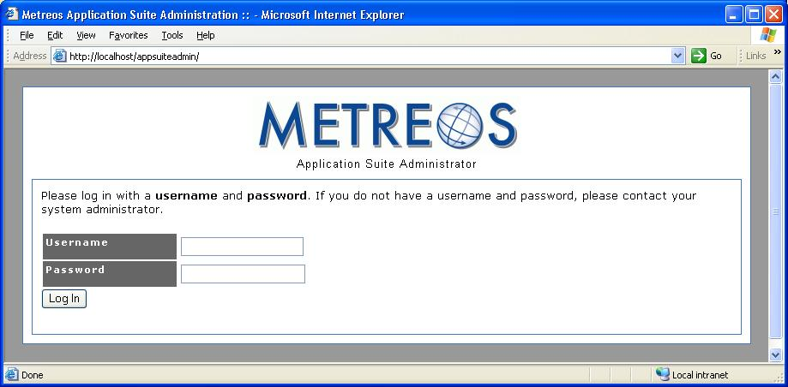
Figure 1: Application Suite Login
The Username is initially set to administrator and the Password is initially set to metreos. After logging in the first time you are given the opportunity to change the password. You can then access the configuration and reporting options of the Metreos Application Suite.

When logging in, the system presents the Main Page of the Metreos Application Suite Administrator:

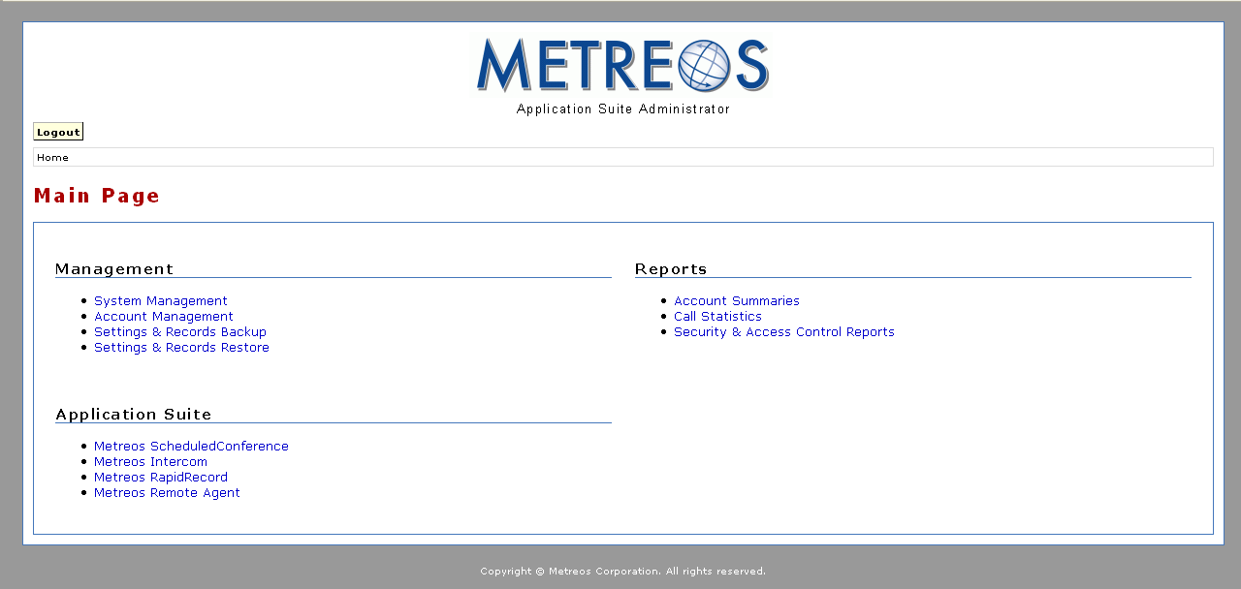
Figure 2: Main Configuration Page
The Application Suite Administrator Main Page is divided into three groups of related management services:

- Management – Allows user and system configuration
- Reports – Allows management of application reports
- Application Suite – Allows configuration of specific applications

Metreos Application Suite Management Interface
The following Management elements are supported:

- System Management – Provides system and application management facilities such as administrator login and password, system-level application configuration, and lockout thresholds.
- Account Management – Permits creation and maintenance of application user accounts.
- Settings & Records Backup – Allows storage of the current Metreos Application Suite state.
- Settings & Records Restore – Allows restoration of a previous Metreos Application Suite state.

System Management
Selecting System Management from the main configuration page displays the System Management page:

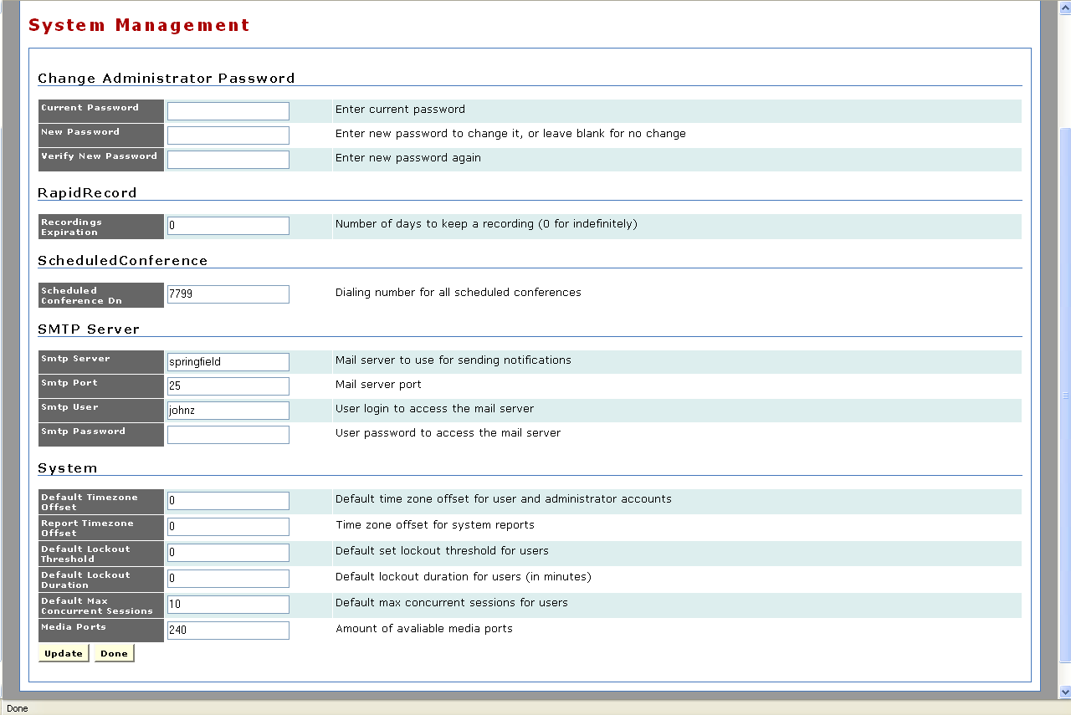
Figure 3: System Management
The System Management page is divided into the following sections:

- Change Administrator Password
- RapidRecord
- ScheduledConference
- SMTP Server
- System

Change Administrator Password
This section allows changing of the Metreos Application Suite administrator password. Use the following procedure:

- Enter the current password in the Current Password field.
- Enter the new password in the New Password field.
- Enter the new password in the Verify New Password field.
- Click the Update button to apply the change.
- Click the Done button to return to the Main Page.

RapidRecord
This section allows specification of the interval in days before call recordings produced by Metreos RapidRecord expire. Use the following procedure:

- Enter the number of days a voice recording should be retained in the Recordings Expiration field.
- Click the Update button to apply the change.
- Click the Done button to return to the Main Page.

Note: An entry of zero indicates that recordings do not automatically expire; they must be manually deleted.

ScheduledConference
This section allows specification of the dial-in number for scheduled conference. Use the following procedure:

- Enter the dial-in number of a currently scheduled conference in the Scheduled Conference Dn field.
- Click the Update button to apply the change.
- Click the Done button to return to the Main Page.

SMTP Server
This section allows the configuration of the SMTP server used for sending e-mail to Metreos ScheduledConference invitees. Populate this section with the following information:

- Smtp Server – Enter the server name or the IP address for the ScheduledConference SMTP e-mail server.
- Smtp Port – Enter the port used by the ScheduledConference SMTP e-mail server.
- Smtp User – Enter the username for the ScheduledConference SMTP e-mail server.
- Smtp Password – Enter the password for the ScheduledConference SMTP e-mail server.

System
This section allows configuration of the Metreos Application Suite support system. Populate this section with the following information:
- Default Time Zone Offset – Enter the difference in hours between the local time and Greenwich Mean Time (GMT) to be used for any account that does not specify a time difference. The value must be positive, negative, or zero. Use a minus sign (-) to designate a negative offset. No sign is necessary to designate a positive offset.
- Report Time Zone Offset – Enter the difference in hours between GMT and local time to be used for the calculation of time stamps in system reports. The value must be positive, negative, or zero. Use a minus sign (-) to designate a negative offset. No sign is necessary to designate a positive offset.
- Default Lockout Threshold – Enter the number of consecutive failed logins before an account is locked, preventing further login attempts. This threshold does not apply to individual accounts for which the lockout has been overridden.
- Default Lockout Duration – Enter the duration in minutes that an account remains locked out. This duration does not apply to individual accounts for which the lockout has been overridden.
- Default Max Concurrent Sessions – Some applications allow multiple concurrent sessions and users can concurrently use multiple applications. Enter the maximum number of concurrent active sessions user accounts are permitted. This parameter does not apply to individual accounts for which maximum concurrent sessions has been overridden.

Account Management
Selecting the Account Management link from the Main Page displays the Account Management page:
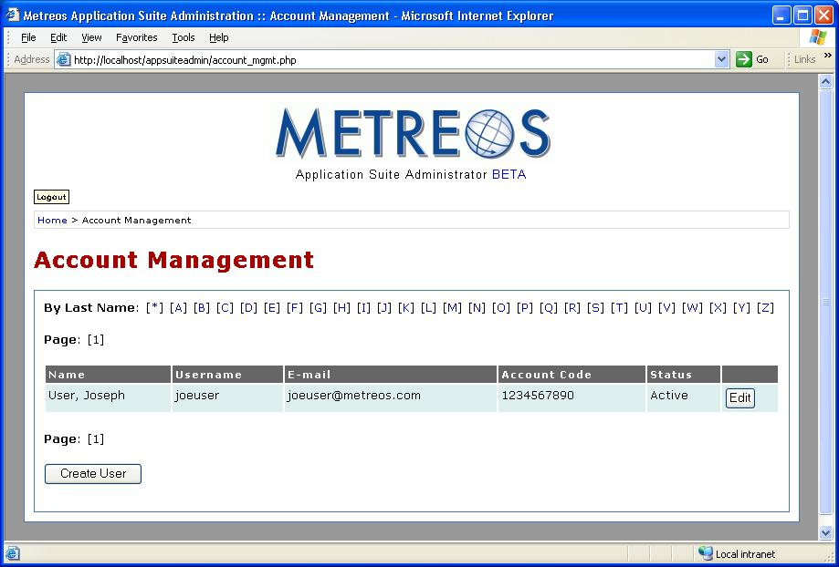
Figure 4: Account Management
Features available on the Account Management page are
- Create User
- Edit User

Create User
Use the following procedure to create a new user account:

- Click the Create User button on the Account Management page to display the Create User page:

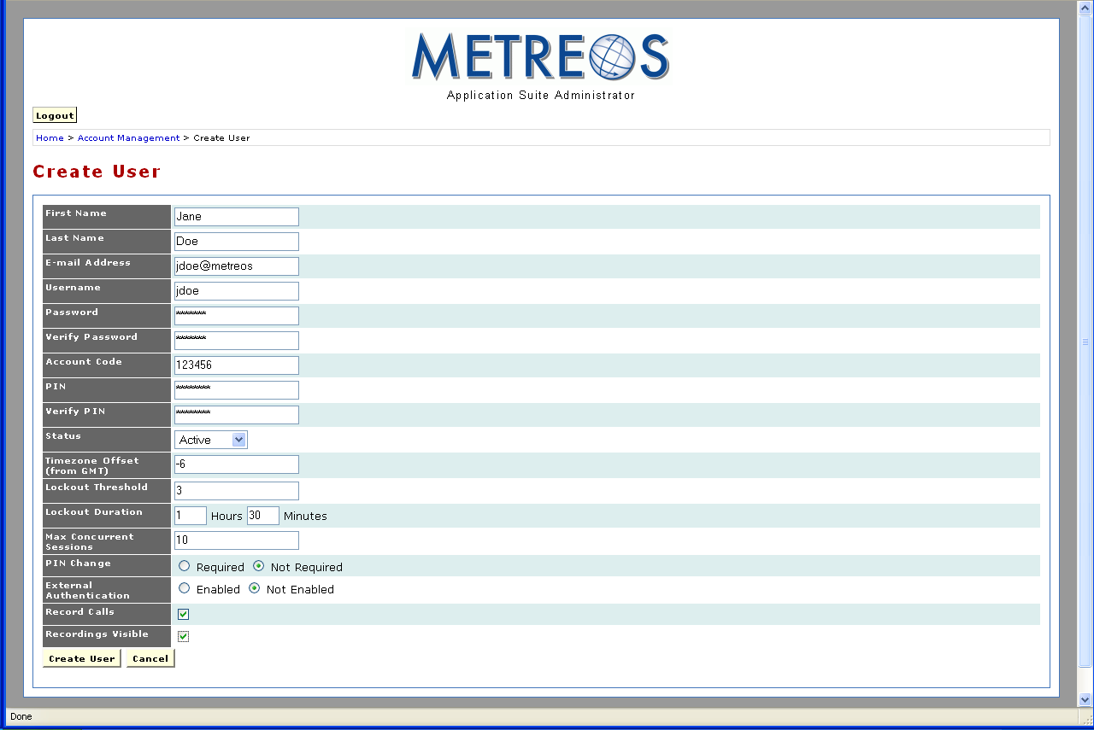
Figure 5: Create User Account
- Complete the fields as described in the following list for the new account:

- First Name – Enter the first name of the user.
- Last Name – Enter the last name of the user.
- E-mail Address – Enter the e-mail address at which the user is to receive Application Suite notifications.
- Username – Enter the username you assign to this user and by which the user is identified.
- Password – Enter the password used to authenticate the user.
- Verify Password – Enter the password used to authenticate the user.
- Account Code – Enter the account number you assign to this user by which the user is identified.
- PIN – Enter the Personal Identification Number used to authenticate the user.
- Verify PIN – Enter the Personal Identification Number used to authenticate the user.
- Status – Enter the user account status. Use the supplied dropdown list:
  - Active
  - Disabled
  - Locked
  - Deleted
- Time Zone Offset (from GMT) – Enter the difference in hours by which the user’s local time differs from GMT. This entry can be positive or negative. Use a minus sign (-) to designate a negative offset. No sign is necessary to designate a positive offset. A default value may have already been set. Refer to System on page 17 for information on default system values.
- Lockout Threshold – Enter the number of consecutive times the user may have a login rejected before the account is forced into a locked out state, preventing further login attempts. A default value may have already been set. Refer to System on page 17 for information on default system values.
- Lockout Duration – Enter the duration in minutes that an account remains locked out. If no entry is supplied for Lockout Duration, the Metreos Application Suite will not automatically unlock a locked account. In such a case you must manually unlock the account. A default value may have already been set. Refer to System on page 17 for information on default system values.
- Max Concurrent Sessions – Some applications allow multiple concurrent sessions and users have access to multiple applications. Enter the maximum number of concurrent sessions for the user. A default value may have already been set. Refer to System on page 17 for information on default system values.
- PIN Change – Checking the Required radio button specifies that the user must change the account PIN at the next login. Checking the Not Required radio button eliminates the requirement of changing the account PIN at the next login.
- External Authentication – Checking the Enabled radio button defers user authentication to the configured LDAP directory. Checking the Disabled radio button disables this feature.
- Record Calls – Checking the box specifies that all calls initiated by this account are to be recorded.
- Recordings Visible – Checking the Recordings Visible box specifies that the user’s phone display will show that the call is being recorded. A button is also displayed to stop and start recording.
Note: CallManager must be configured for each recorded device. Refer to Appendix A: Cisco CallManager Configuration on page 72 for more information.
- Click the Create User button to create the user account.

Edit Account
Use the following procedure to edit a user’s account:

- Click the Edit button on the Account Management page for the user whose account you want to edit. The system displays the edit account page:

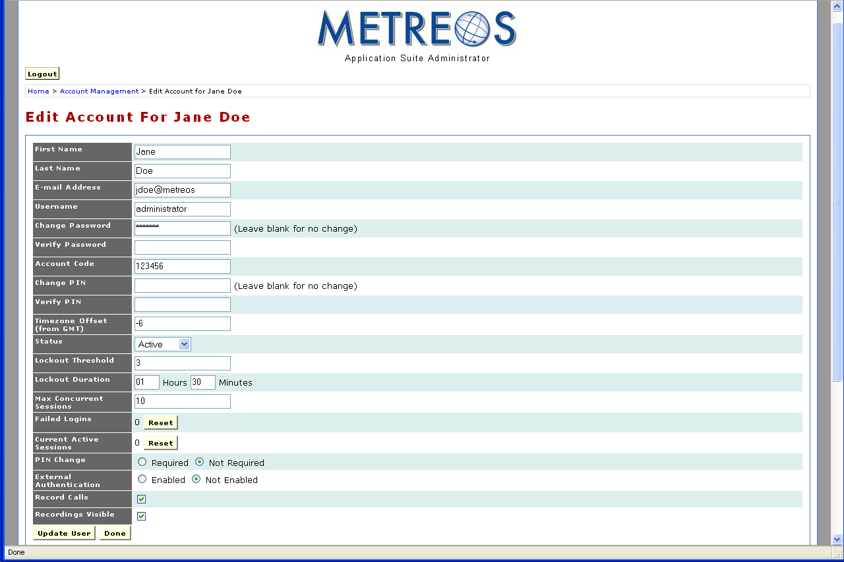
Figure 6: Edit Account Page
- Make any required changes to the user account. Refer to Create User on page 20 for field descriptions.
- Click the Update User buttton to affect the change. Click the Done button to return to the Account Management page.

Scroll down the Edit Accounts to view three additional sections:

- Devices
- External Numbers
- Remote Agent

Devices
The Devices section lists device MAC addresses and their associated numbers at which this user can be reached:

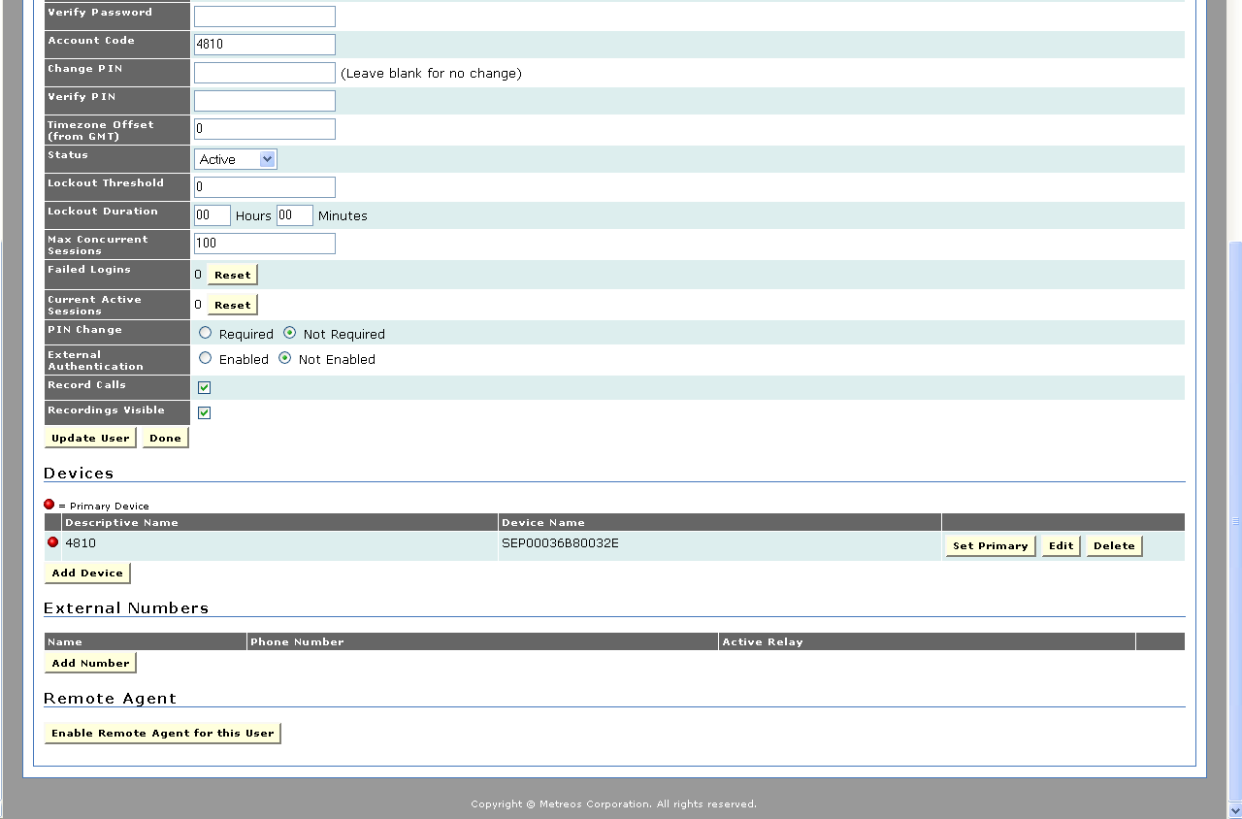
Figure 7: Devices Section
Use the following procedure to add a new device:

- Click the Add button:

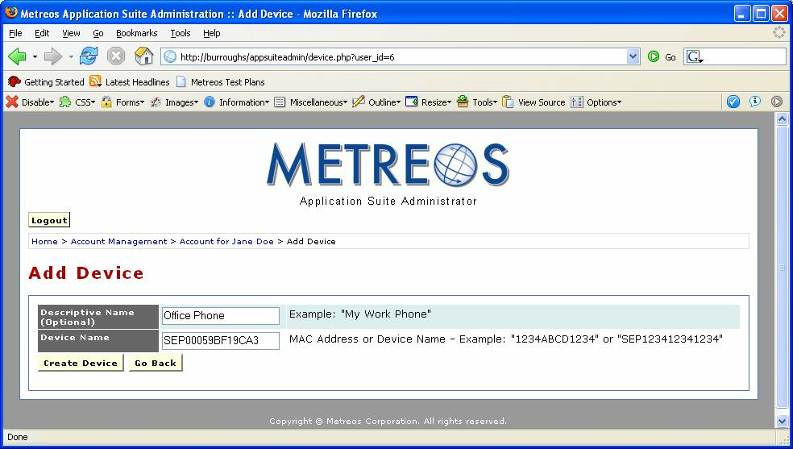
Figure 8: Add Device Page
- Add a descriptive name for the device in the Descriptive Name field.
- Enter the MAC address in the Device Name field. You can retrieve the MAC address from your phone. Each supported IP phone has three labels affixed to the bottom of the phone, and each label contains a human-readable, 12-digit, alphanumeric string and a barcode. The MAC address is the 12-digit string located on the center label.
- Click the Create Device button to add the device. The system presents the Edit Device page:

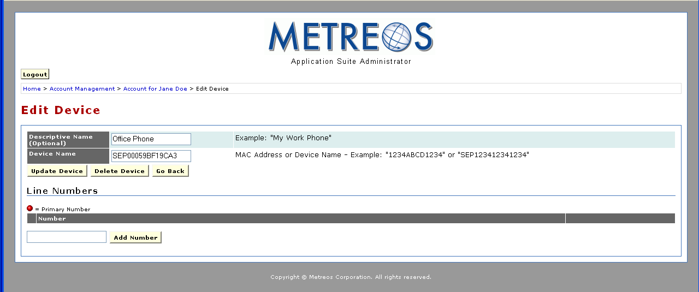
Figure 9: Edit Device Page
- Enter the directory number listed in CallManager for the device in the Add Number field. You can add as many numbers for each device as necessary.

As many devices can be added as necessary. One of the devices must be set as the primary device. The designation of a primary device is strictly for the use of applications that require a single device. Such applications will call the only device designated as primary. The Devices section of the edit user account contains a Set Primary button for each device:

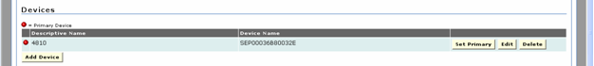
Figure 10: Devices Section of Edit User Containing Set Primary Button
Click the Set Primary button associated with the user’s primary device. You can also edit and delete numbers using the Edit and Delete buttons for each device.

External Numbers
The External Numbers section allows the specification of numbers for use with Metreos ActiveRelay, a call forwarding application:

Figure 11: External Numbers Section of Edit User
ActiveRelay routes calls placed to the primary device and makes them available on all enabled devices in the External Numbers section. Refer to Metreos ActiveRelay Configuration on page 38 for more information about ActiveRelay and its configuration.

Use the following procedure to specify external numbers and enable ActiveRelay:

- Click the Add Number button. The system displays the Add Number page:

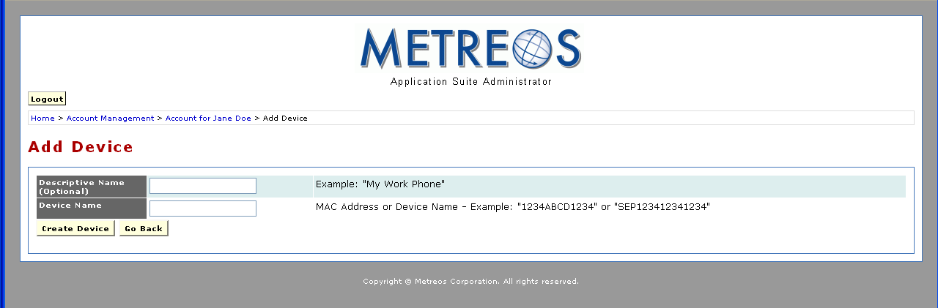
Figure 12: Add Number Page
- Enter a descriptive name in the Name (Optional) field.
- In the Phone Number field, enter the fully qualified directory number of the physical phone on which the User will be receiving calls.
- Check the Active Relay box.

Remote Agent
The Remote Agent section is used to configure the Metreos RemoteAgent application. Contact your Metreos representative for information about Metreos RemoteAgent.

Settings & Records Backup
Use the following procedure to back up the Metreos Application Suite:

- Click the Settings & Records Backup link on the Main Page. The system displays the All Backups Page:

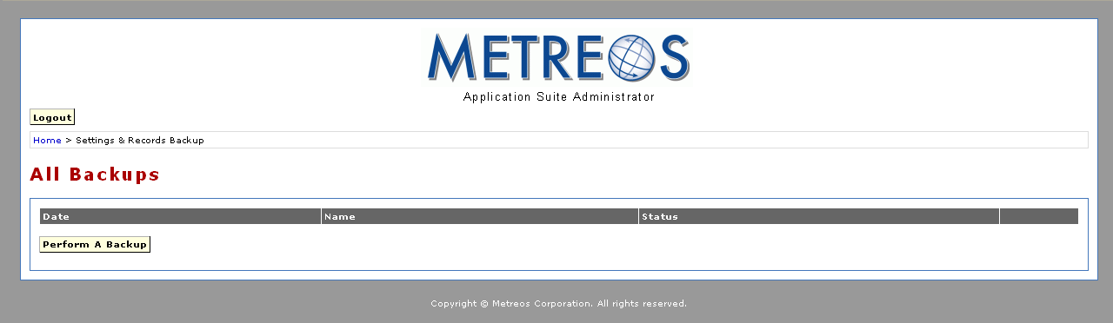
Figure 13: All Backups Page
- Click the Perform a Backup button. The system displays the Performing a Backup page:

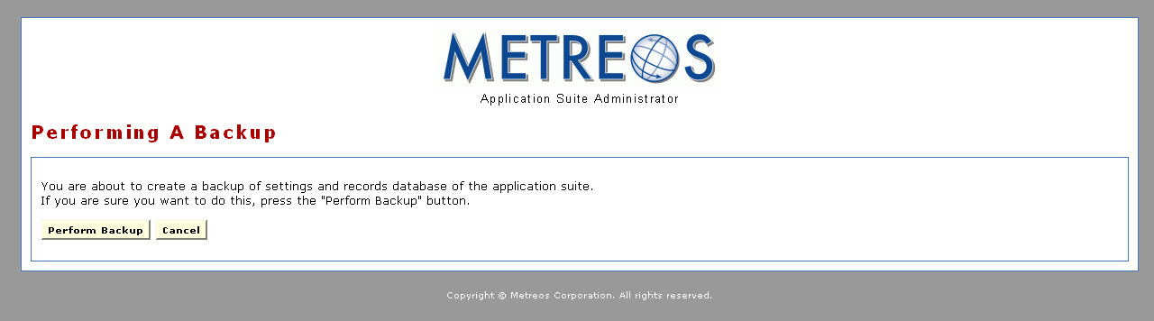
Figure 14: Performing a Backup Page
- Click the Perform Backup button. The system displays a message indicating whether the backup completed succesfully:

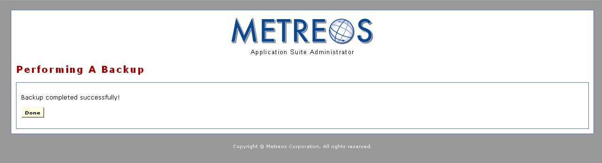
Figure 15: Backup Successful Message
- Click the Done button to return to the All Backups page. The system automatically populates the All Backups page with your backups:

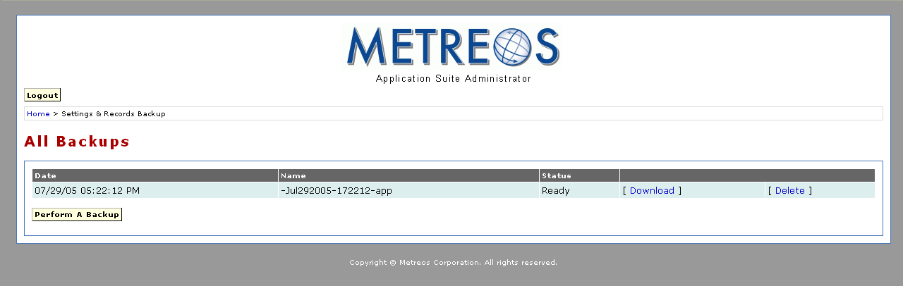
Figure 16: Updated All Backups Page
You now have the option of downlowding the backup file by clicking the Download button or deleting the backup file by clicking the Delete button.

Settings & Records Restore
Use the following procedure to restore the Metreos Application Suite to a previously stored state:

- Click the Settings & Records Backup link on the Main Page. The system displays the Restore page:

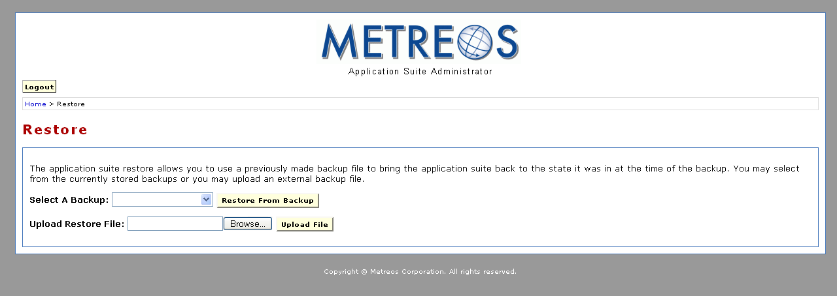
Figure 17: Restore Page
You have two options for restoring the Application Suite:
- Select a backup file from the Select a Backup dropdown list and click the Restore From Backup button.
- Browse for a previously downloaded backup file using the Browse... button and click the Upload File button once you have located the file.
The system displays the Perform a Restore page:

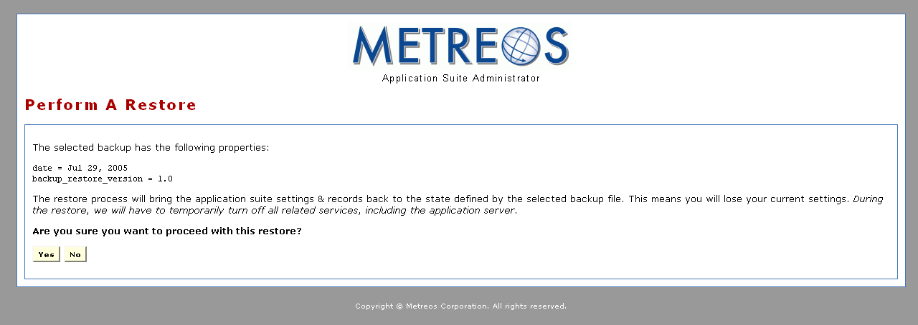
Figure 18: Perform A Restore Page

- Click the Yes button to procede. The system displays a message indicating whether the restoration completed succesfully:

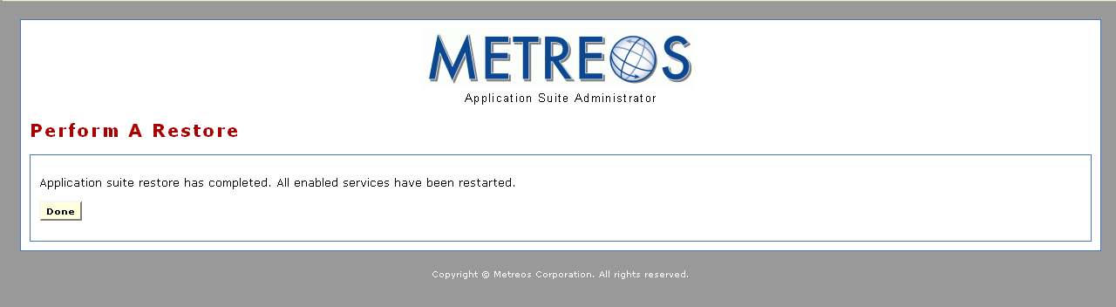
Figure 19: Restoration Complete
- Click the Done button to return to the Restore page.

Application Suite Reports
The Metreos Application Suite reporting facility permits the accumulation and presentation of statistics and metrics pertaining to the account usage of each application in the suite. Reported statistics are commonly used for billing calls, detecting intrusion, and maintaining a record of customer contacts. All such administration reports can be accessed from the Main Page of the Application Suite Administrator:

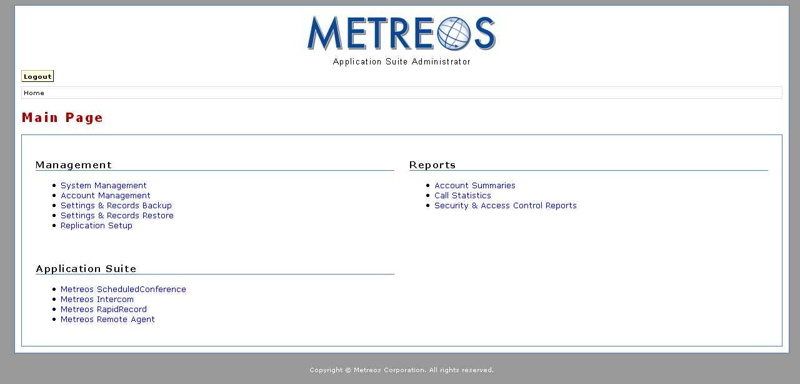
Figure 20: Main Configuration Page
Available reports are

- Account Summaries – Presents calls by account code, filtered by selected criteria
- Call Statistics – Presents calls placed to selected clients, and associated with selected projects
- Security and Access Control – Presents statistics on each device accessing each account

Account Summaries
Click the Account Summaries link to display the Account Summary page:

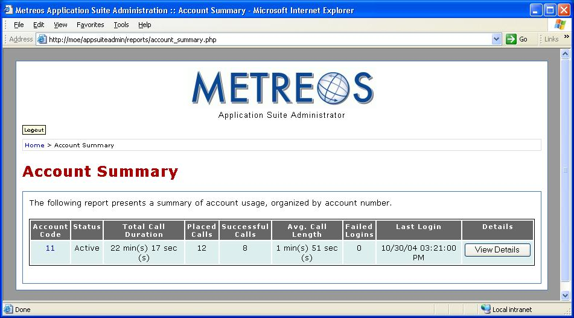
Figure 21: Account Summary Page
Account Summary reports present statistics for each account code such as cumulative call duration, average call length, and last login.

Call Statistics Reports
Click the Call Statistics link to display the Call Statistics page:

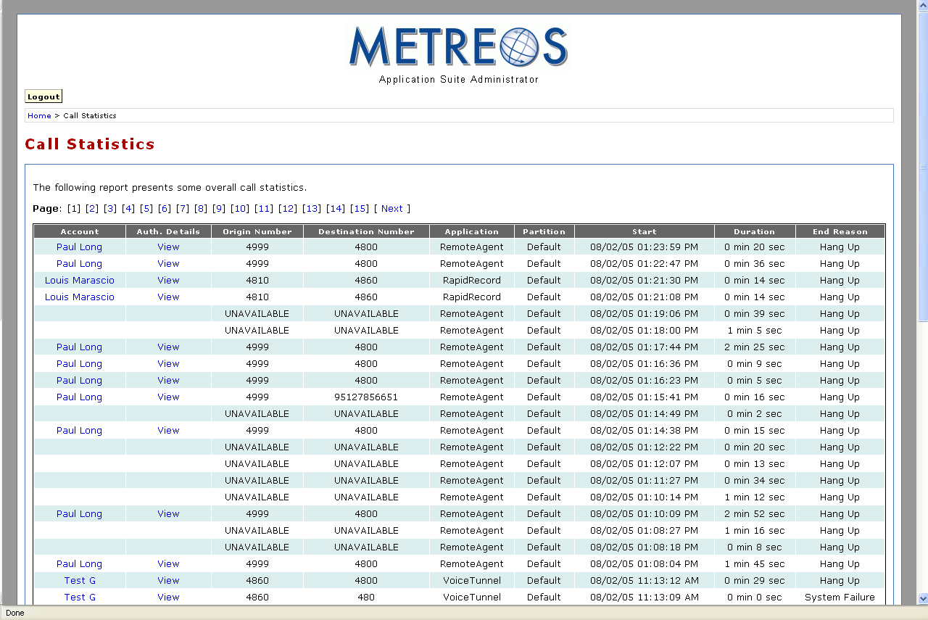
Figure 22: Call Statistics Report Page
Call Statistics reports show statistics of calls placed from selected accounts to specific clients, and that are associated with selected projects.

Security and Access Control Reports
Click the Security & Access Control Reports link to display the Security & Access Control Reports page:

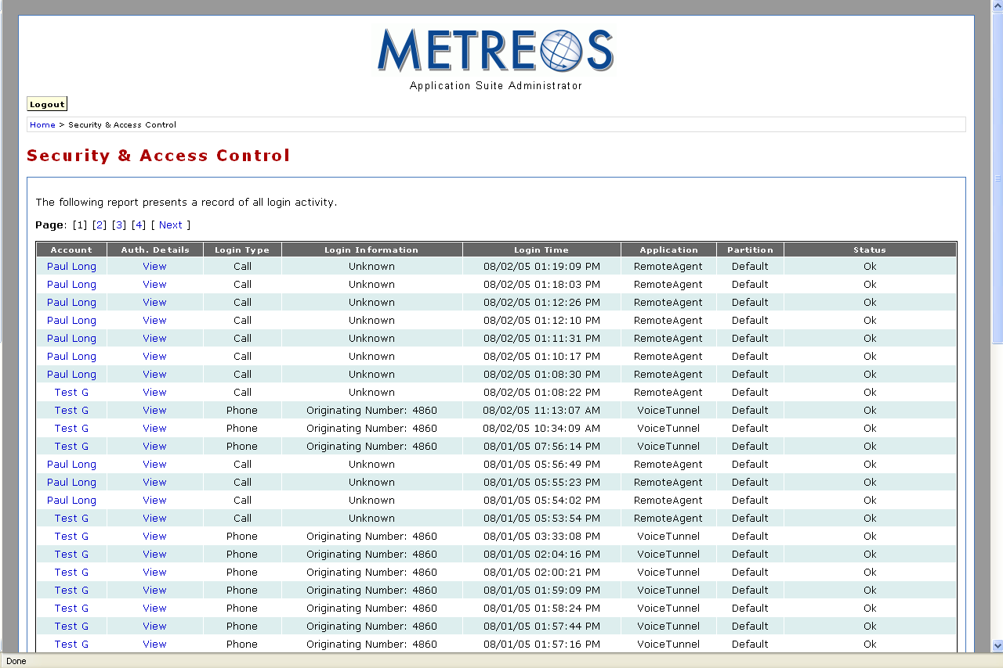
Figure 23: Security And Access Control Reports
Security and Access Control reports display detailed information on which devices are using which account codes. If an account is locked out or an unexpected concurrent sessions exceeded error occurs, this page can be used to determine the device from which the offending attempt was initiated.

Application Configuration
Applications in the Metreos Application Suite require installation and configuration. Cisco CallManager may also require application-specific configuration. Refer to Appendix A: Cisco CallManager Configuration on page 72 for information on application specific settings in CallManager.

Setting the Trigger Parameter for Metreos Applications
Each application script in the Metreos Application Suite has a set of triggering parameters. The parameters are set in the MCE using the Metreos Management Console. You can find detailed information about the Metreos Management Console in the Metreos Communications Environment 2.1 Management Console User Guide. Cisco CallManager must also be configured such that calls are routed to the Metreos Application Runtime Environment.

The following procedure describes how to set the trigger value for applications in the Metreos Application Suite:

- Launch the Metreos Management Console and log in:

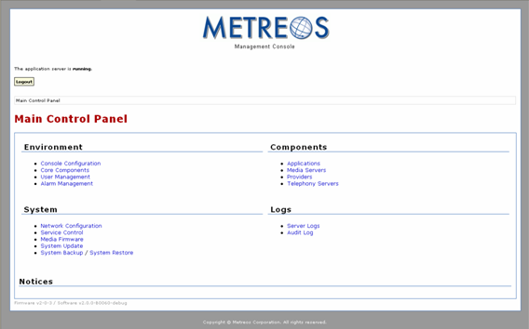
Figure 24: Metreos Management Console
- Click the Applications link to display the Applications page:

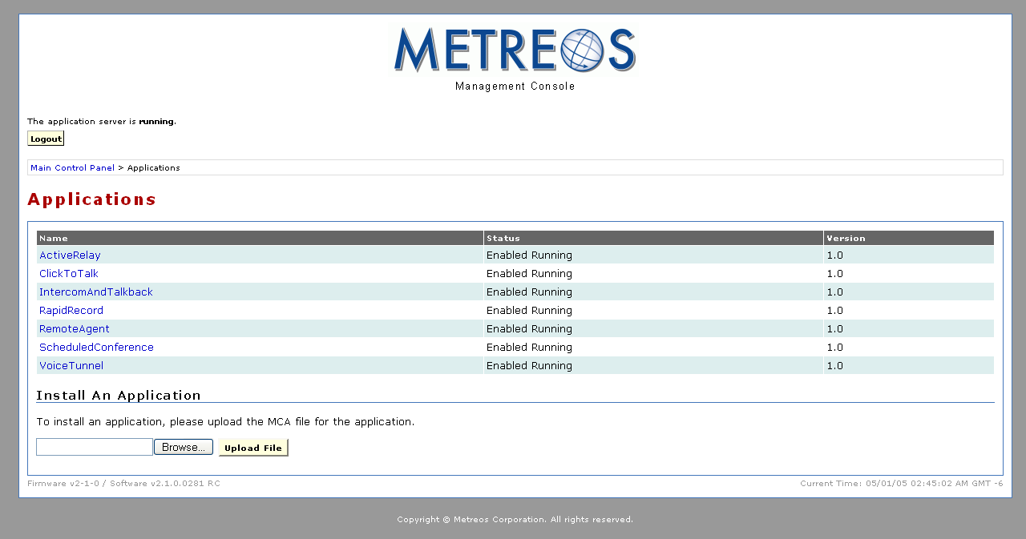
Figure 25: Metreos Managmenet Console Applications Page
- Select the application for which you want to set the trigger parameter, ScheduledConference, for example:

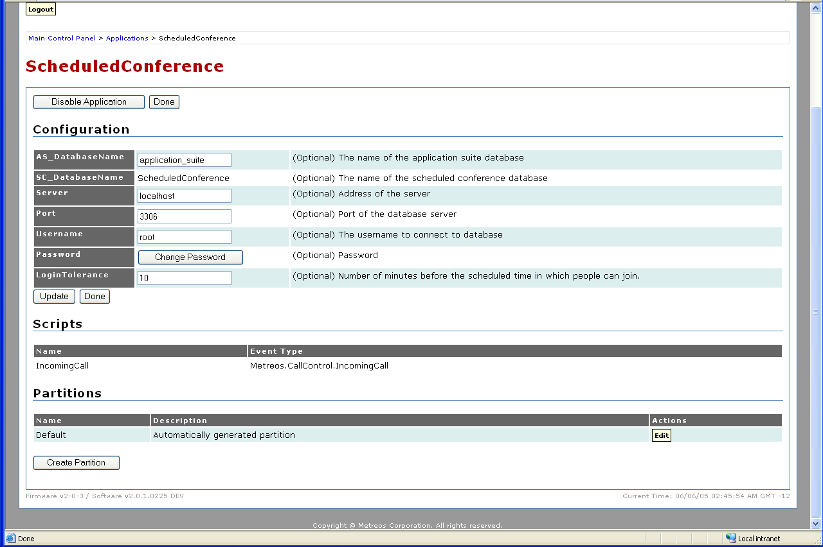
Figure 26: Application Configuration Page for Metreos ScheduleConference

- Click the Edit button at the bottom of the page in the Partitions section:

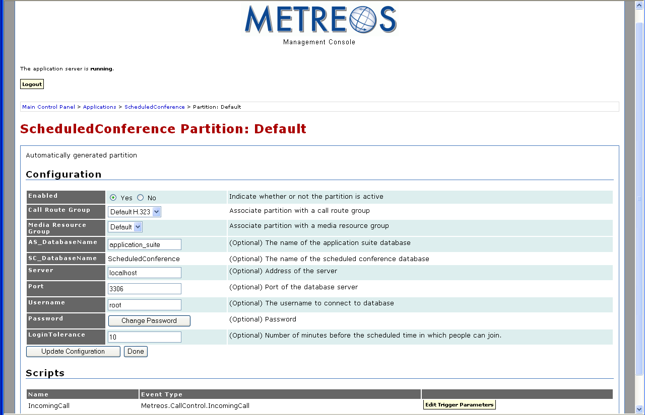
Figure 27: Default Application Partition Page for Metreos ScheduleConference
The Scripts section lists the script name (IncomingCall) and the event type (Metreos.CallControl.IncomingCall).

- Click the Edit Trigger Parameters button to set the trigger event script parameters:

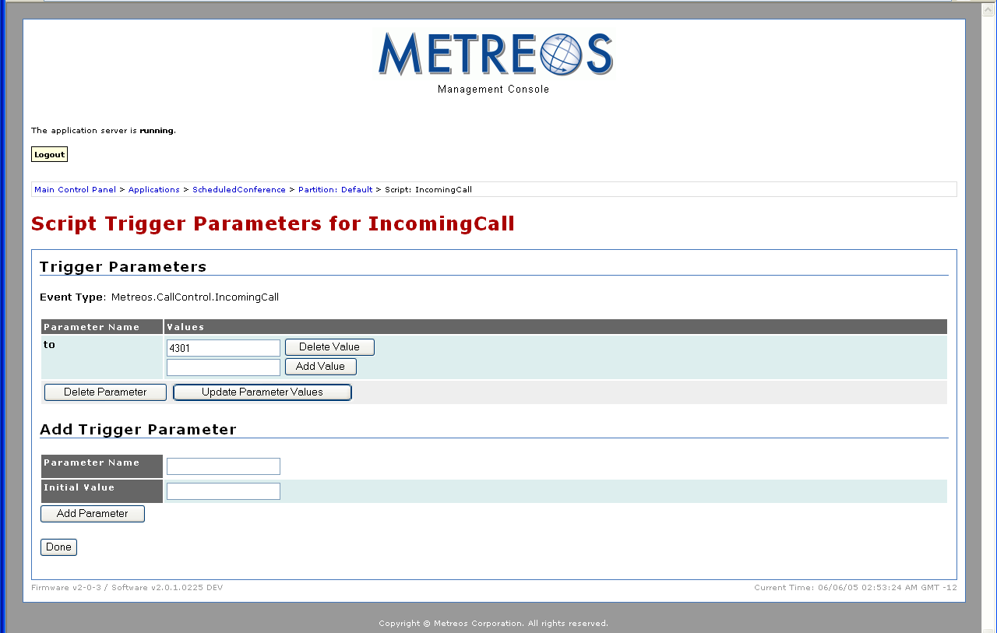
Figure 28: Trigger Parameter Page for Metreos ScheduleConference
In the given example, ScheduledConference, the trigger event is Metreos.CallControl.IncomingCall, which occurs when the system receives an incoming call. On receipt of this event the application runtime seeks a match between the extension in the trigger parameter and the extension of the incoming call. If such a match is found, the script—in this case, IncomingCall—is executed. The administrator sets the extension by entering it in the Add Value field and clicking the Add Value button.

Although Metreos applications may be triggered by various event types, all triggering events in the Metreos Application Suite are either incoming calls or HTTP events. HTTP events have URL trigger parameters rather than extensions as incoming calls do. In the Application Suite, a URL trigger is used either to execute a query or to display information on a phone.

Some applications have multiple scripts, each of which has a trigger event. The following table presents each Metreos application, all of its trigger event scripts, and the required trigger parameter value:

Application | Trigger Event Script | Event Type | Name/ Value Pair
Metreos ActiveRelay | IncomingCall | OnIncomingCall | to = set by administrator (per user)
 | SwapScript | HTTP | url = /ActiveRelay
Metreos ClickToTalk | Ping | HTTP | url = /click-to-talk/validate
 | StopRecording | HTTP | url = /click-to-talk/stopRecord
 | GetErrors | HTTP | url = /click-to-talk/errors.xml
 | AppImage | HTTP | url = /click-to-talk/image.xml
 | Call_Initiator | HTTP | url = /click-to-talk/initiateCall
 | AddCallToConference | OnIncomingCall | to = set by administrator
Metreos Intercom | IntercomAddWorker | HTTP | url = /IntercomAddWorker
 | ShowIntercomGroups | HTTP | url = /ShowIntercomGroups
 | LaunchIntercom | HTTP | url = /LaunchIntercom
Metreos RapidRecord | Record | OnIncomingCall | to = regex:99999.+
 | InitiateRetrieveControlKeys | HTTP | url = InternalSendEvent
Metreos ScheduledConference | IncomingCall | OnIncomingCall | to = set by administrator
Metreos VoiceTunnel | CallRouter | OnIncomingCall | to = set by administrator
Table 1: Application Triggering Event Parameters

Metreos ActiveRelay Configuration
Metreos ActiveRelay lets you receive calls at a single number, regardless of your physical location. It can, for example, bridge your cellular telephone to your office telephone and simultaneously ring both phones, allowing you to answer either phone.

Once connected, you can easily transfer the call to other devices that are configured with ActiveRelay. The call also does not exhibit multiple ring sequences as do older style call forwarding applications.

Installing the Cisco IP Phone Service
Before Metreos ActiveRelay can be used, the phone service must be installed on CallManager, and the participating phones subscribed to the service. Refer to Cisco IP Phone Services Setup on page 74 for details.

Configuring Metreos ActiveRelay
Use the following procedure to configure Metreos ActiveRelay:

- Launch the Metreos Management Console and log in:

Figure 29: Metreos management Console
- Click the Applications link

Figure 30: Metreos Management Console Applications Page
- Click the ActiveRelay link:

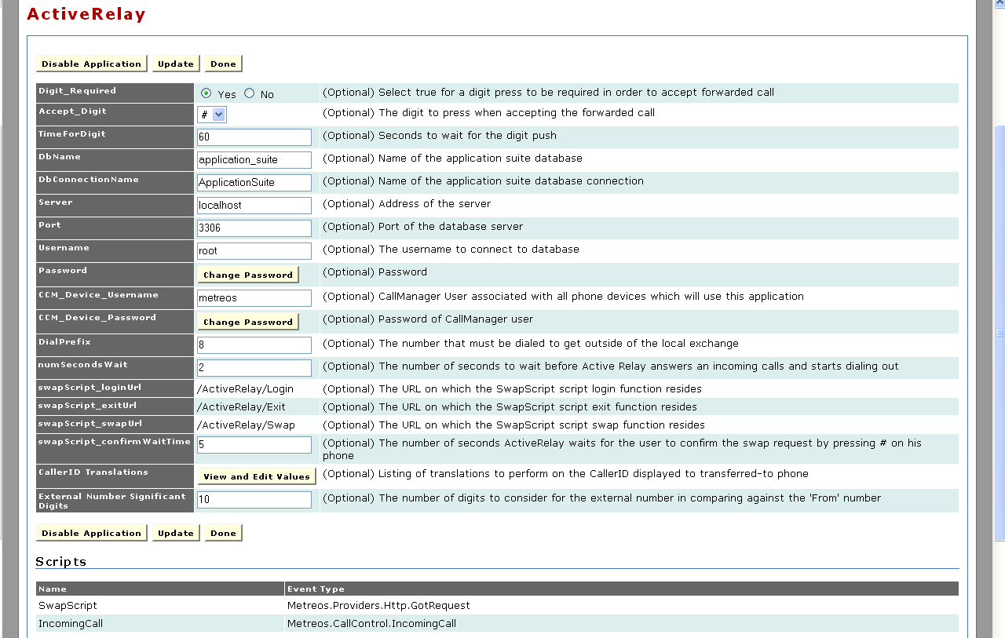
Figure 31: Metreos ActiveRelay Configuration Page
- Fill out the form in accordance with the following list:

  - Digit_Required – ActiveRelay provides the option of requiring the user to press a specified key on the phone keypad to accept a forwarded call. The Yes radio button enables this feature. The No radio button disables this feature.
  - Accept_Digit – Enter the key the user will press to accept a forwarded call if that feature is enabled.
  - TimeForDigit – Enter the maximum interval in seconds the user can wait before pressing the key to accept a forwarded call if that feature is enabled.
  - DbName – Enter the name of the Metreos Application Suite database.
  - DbConnectionName – Enter the name of the database connection.
  - Server – Enter the application server address.
  - Port – Enter the database port number.
  - Username – Enter the username associated with the Metreos Application Suite account that should be used to connect to the database. Refer to Account Management on page 19 for information on usernames.
  - Change Password – Click the Change Password button to change the password used to connect to the database. You will be prompted for your current password, the new password, and be prompted to verify the new password. After entering the new password click the Update button.
  - CCM_Device_Username – Enter the Cisco CallManager username associated with phones that use Metreos ActiveRelay.
  - CCM_Device_Password – Click the Change Password button to change the password for the CallManager username. You will be prompted for your current password, the new password, and be prompted to verify the new password. After entering the new password click the Update button.
  - DialPrefix – Enter the number required to connect to an external phone.
  - numSecondsWait – Enter the delay in seconds ActiveRelay between receiving a call and forwarding the call to the forwarding number.
  - swapScript_loginUrl – ActiveRelay uses a swap script to switch a forwarded call from a mobile device to your desk phone while the forwarded call is in progress. The swap script uses a series of URLs to switch a call from one phone to another. The swapScript_loginURL parameter specifies the URL used to log into your desk phone. This parameter is preset by Metreos and may not be changed by the administrator.
  - swapScript_exitUrl – The swap script uses this URL to end interaction with the phone. This parameter is preset by Metreos and may not be changed by the administrator.
- swapScript_swapUrl – The swapScript_swapUrl parameter is preset by Metreos. The swapScript_swapUrl field is read-only.
- swapScript_confirmWaitTime – Users must confirm that they want to swap the call by pressing the pound (#) key. Enter the maximum interval in seconds between the time the user initiates the swap and confirms the swap.
- CallerID Translations – This parameter permits identification of internal calls. When a call is forwarded to your phone, your phone displays the incoming call number. The incoming call number is a fully qualified directory number if the call is external. Internal calls, however, typically do not require dialing the full number.

A common practice, for example, is to configure your internal dial plan to allow users to dial only the last four digits of the outside line associated with another user in the system. Another common practice for large systems is to allow users to dial a 5-digit number, in which the first digit signifies a physical location and the last 4 digits are used to match the user being called. The CallerID Translations parameter is used to construct a fully qualified directory number for internal calls so that the full number can be displayed when the call is forwarded.

The CallerID Translations parameter uses a key/value pair to construct the fully qualified directory number. A regular expression is used to determine whether the call is internal and—if so—the regular expression adds an area code and prefix to the internal number. Refer to http://msdn.microsoft.com/library/default.asp?url=/library/en-us/cpgenref/html/cpconRegularExpressionsLanguageElements.asp for information about regular expressions.

- If the internal dial plan specifies the last four digits plus a leading number representing a physical location, use the following regular expression:

Key ^[0-9\*#](?<internal>[0-9\*#]{4})$ Value xxxyyy${internal}

The first expression in brackets ( [ ] )causes deletion of the initial digit, isolating the last four digits in preparation for constructing the fully qualified directory number.

The 4 in curly braces at the end of the Key field is used to identify incoming calls with four digit numbers. If your facility uses a different number of digits for internal calling, you can vary this number to match the number of digits used for your internal calls

The characters in the Value field represent the area code and prefix for your facility.

- If the internal dial-plan specifies the last four digits of the directory number, use the following regular expression:

Key ^(?<internal>[0-9\*#]{4})$ Value xxxyyy${internal}

The 4 in curly braces at the end of the Key field is used to identify incoming calls with four digit numbers. If your facility uses a different number of digits for internal calling, you can vary this number to match the number of digits used for your internal calls. The characters in the Value field represent the area code and prefix for your facility.

- If the internal dial plan is different than other the two dial plans described in this section, refer to http://msdn.microsoft.com/library/default.asp?url=/library/en-us/cpgenref/html/cpconRegularExpressionsLanguageElements.asp for information about regular expressions.

When you have identified the required regular expression

  - Click the View and Edit Values button:

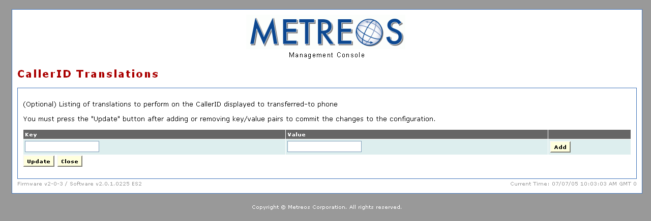
Figure 32: CallerID Translations Page
  - Enter the key regular expression in the Key field.
  - Enter the area code and prefix for your facility followed by the regular expression ${internal} in the Value field as shown:

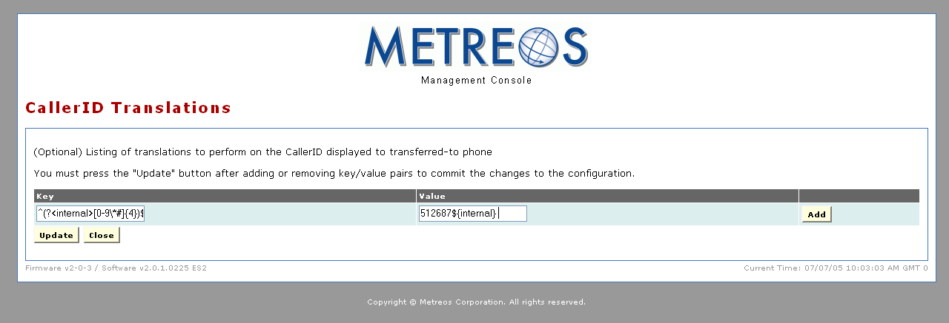
Figure 33: Example CallerID Translations Key/Value Pair
  - Click the Add button.
  - Click the Update button.

- Click the Update button on the ActiveRelay Configuration page.
- Set the trigger parameter using the procedure in Setting the Trigger Parameter for Metreos Applications on page 34.

Adding a User to Active Relay
Use the following procedure to add a user to Active Relay:

- Launch the Metreos Management Console and login:

Figure 34: Metreos management Console
- Click the Applications link

Figure 35: Metreos Management Console Applications Page
- Click the Active Relay link:

Figure 36: Metreos ActiveRelay Configuration Page
- Click the Edit button associated with the partition for which you want to add a user:

Figure 37: Active Relay Partition Configuration Page
- Click the Edit Triggering Parameters button for the IncomingCall script:

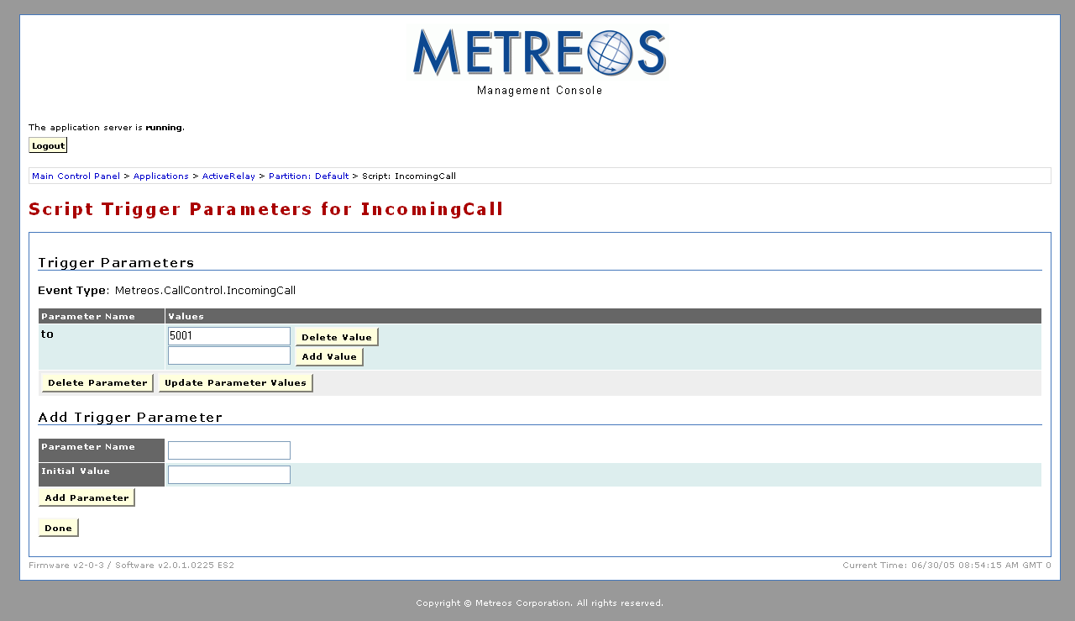
Figure 38: Active Relay IncomingCall Script Trigger Parameters Page
- Enter a directory number for the user you want to add in the Add Value field.
- Click the Add Value button.
- Click the Done button.

Metreos ClickToTalk Configuration
Metreos ClickToTalk is a speed dialing application allowing calls to any party in a contact list with a single click. Metreos ClickToTalk can be used by anyone in a Cisco CallManager group using a Cisco 7940, 7960, or 7970 IP telephone.

A ClickToTalk user can call a Microsoft Outlook contact by highlighting a contact and clicking a button on the Outlook toolbar. ClickToTalk then dials the selected contact from the user’s IP phone. Conferencing and recording of calls are also supported. Recorded calls can be sent by e-mail to all call participants.
Use the following procedure to configure Metreos ClickToTalk:

- Launch the Metreos Management Console and login:

Figure 39: Metreos management Console
- Click the Applications link

Figure 40: Metreos Management Console Applications Page
- Click the ClickToTalk link:

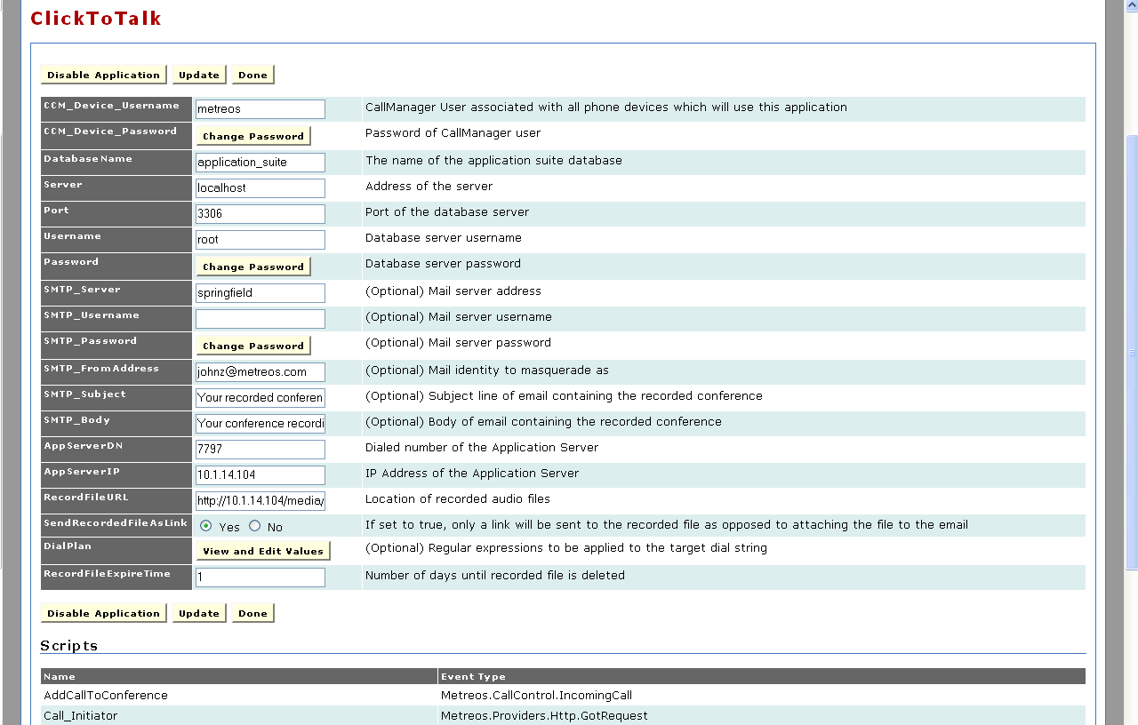
Figure 41: Metreos ClickToTalk Configuration Page
- Fill out the form in accordance with the following list:

  - CCM_Device_Username – Enter the Cisco CallManager username associated with phones that use Metreos ClickToTalk.
  - CCM_Device_Password – Click the Change Password button to change the password used to connect to the database. You will be prompted for your current password and the new password, and you will be prompted to verify the new password. After you have done so click the Update button.
  - Database Name – Enter the name of the Metreos Application Suite database.
  - Server – Enter the application server address.
  - Port – Enter the database port number.
  - Username – Enter the username used to connect to the database.
  - Password – Click the Change Password button to change the password used to connect to the database. You will be prompted for your current password and the new password, and you will be prompted to verify the new password. After you have done so, click the Update button.
  - SMTP_Server – Enter the e-mail server address used to send recorded calls.
  - SMTP_Username – Enter the username used for access to the mail server designated above.
  - SMTP_Password – Click the Change Password button to change the password used to connect to the database. You will be prompted for your current password and the new password, and you will be prompted to verify the new password. After you have done so, click the Update button.
  - SMTP_FromAddress – e-mail address used to identify the sender of forwarded call recordings.
  - SMTP_Subject – Enter the subject line of the e-mail message used to send recorded calls.
  - SMTP_Body – Enter the information you want to include in the body of the e-mail message used to send recorded calls.
  - AppServerDN – Enter the to value of the trigger parameter for Metreos ClickToTalk. Refer to Setting the Trigger Parameter for Metreos Applications on page 34 for details about Metreos application trigger parameters.
  - AppServerIP – Enter the IP address of the application server.
  - RecordFileURL – Enter the URL for the recorded messages file location.
  - SendRecordedFileAsLink – Click the Yes radio button if recordings are to be sent as links. Click the No radio button if recordings are to be sent as e-mail attachments.
  - DialPlan – ClickToTalk supports external calls. Most systems are configured to require users making outside calls to precede a fully qualified directory number with a digit such as 9.

The DialPlan parameter uses a key/value pair in the form of a regular expression to add the preceding digit. Refer to http://msdn.microsoft.com/library/default.asp?url=/library/en-us/cpgenref/html/cpconRegularExpressionsLanguageElements.asp for more information about regular expressions.

If the dial plan is configured to require a leading 9 for external calls, use the following regular expression:

Key ^(?<extNum>[0-9\*#]{7,99})$ Value 9${extNum}

If the dial plan requires a digit other than 9, replace the 9 in the Value field with the required digit. To configure the external call digit for ClickToTalk

- Click the View and Edit Values button:

Figure 42: CallerID Translations Page
- Enter the Key expression in the Key field, and enter the Value expression in the Value field as shown:

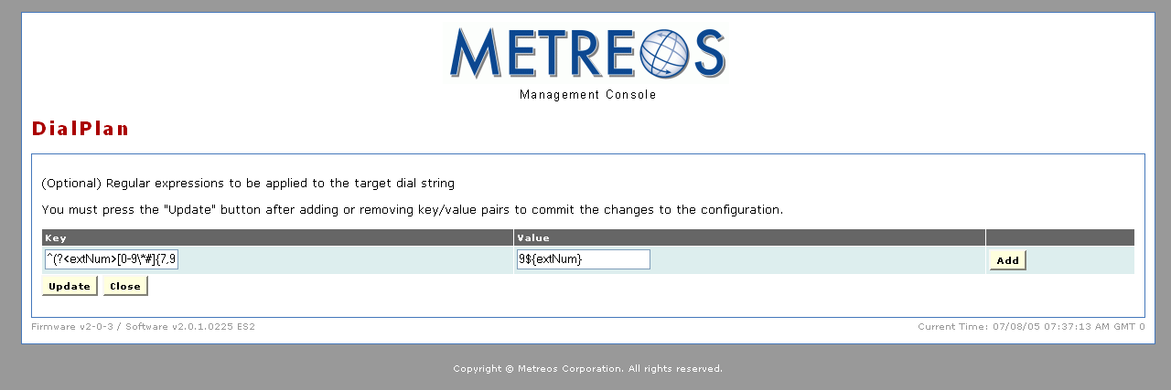
Figure 43: Example DialPlan Translations Key/Value Pair
- Click the Add button.
- Click the Update button.

  - RecordFileExpireTime – Enter the interval in days you want to keep call recordings before expiration.

- Click the Update button on the ClickToTalk configuration page.
- Set the trigger parameter using the procedure in Setting the Trigger Parameter for Metreos Applications on page 34.

Metreos Intercom Configuration
Metreos Intercom permits instant communication over IP phones without the need to dial a number. Users select from a contact group on the IP phone display, and audio connectivity is established.

Metreos Intercom can also be configured to act as a group paging system for broadcasting voice messages or pages in a fashion similar to a traditional paging system. Using the TalkBack feature, an intercom listener can press the Reply button and instantly conference with each party in the intercom group.

Configuring Metreos Intercom is a three step process:

- Install the Cisco IP phone service
- Create intercom groups
- Configure Metreos Intercom

Installing the Cisco IP Phone Service
Before Metreos Intercom can be used, the phone service must be installed on CallManager, and the participating phones subscribed to the service. Refer to Cisco IP Phone Services Setup on page 74 for details.

Creating Intercom Groups
Metreos Intercom employees the concept of an intercom group. An intercom group is an aggregation of Metreos Intercom users created by the administrator. To broadcast a Metreos Intercom message, select an intercom group on the IP phone display. You can then speak normally without lifting the handset, and the voice message is broadcast to the phone speaker of each group member.

If the administrator has defined the intercom group as public, anyone can join or leave the group once it has been created. If the administrator has designated the group as private, its membership is determined solely by the administrator.

Use the following procedure to create an intercom group

- Select Metreos Intercom from the Main page of the Metreos Application Suite Administrator. The system presents the Metreos Intercom page:

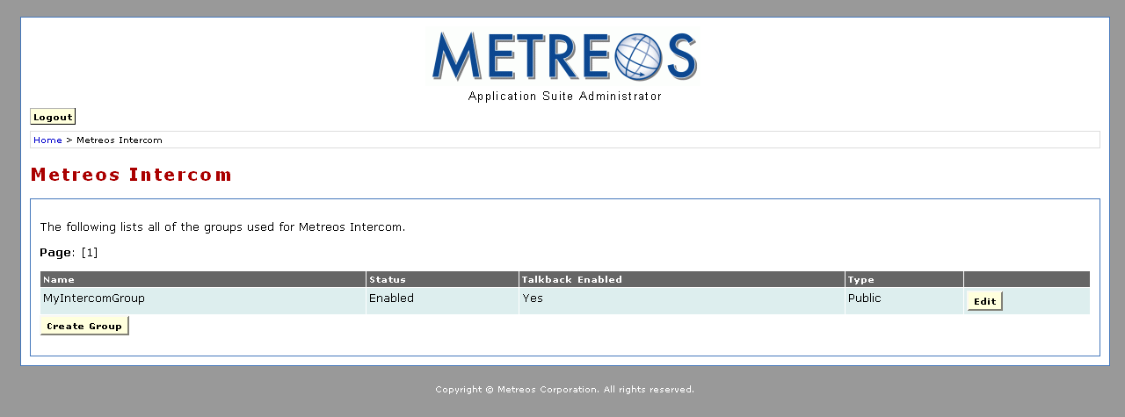
Figure 44: Metreos Intercom Page

- Click the Create Group button. The system displays the Create Intercom Group page:

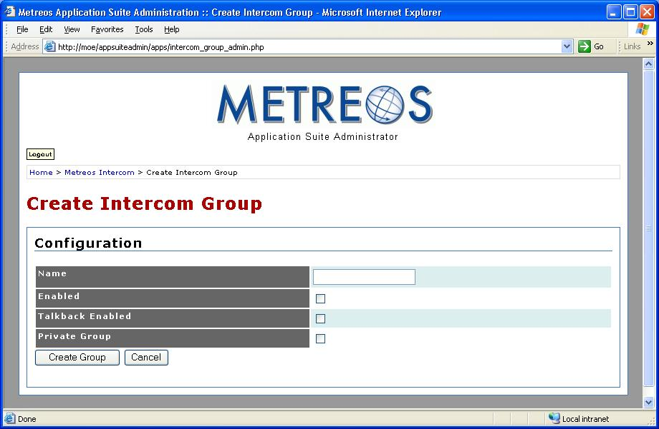
Figure 45: Create Intercom Group
- Fill out the form in accordance with the following list:

- Name – Enter the group name.
- Enabled – Check the box to enable the intercom group.
- Talkback Enabled – Check the box allow non-initiating members of the group to talk over the intercom channel rather than only listen.
- Private Group – Check the box to designate the intercom group private (only the administrator can add and remove users). Leave unchecked to designate the intercom group as public (any user can join or leave the group at will).

- Click the Create Group button:

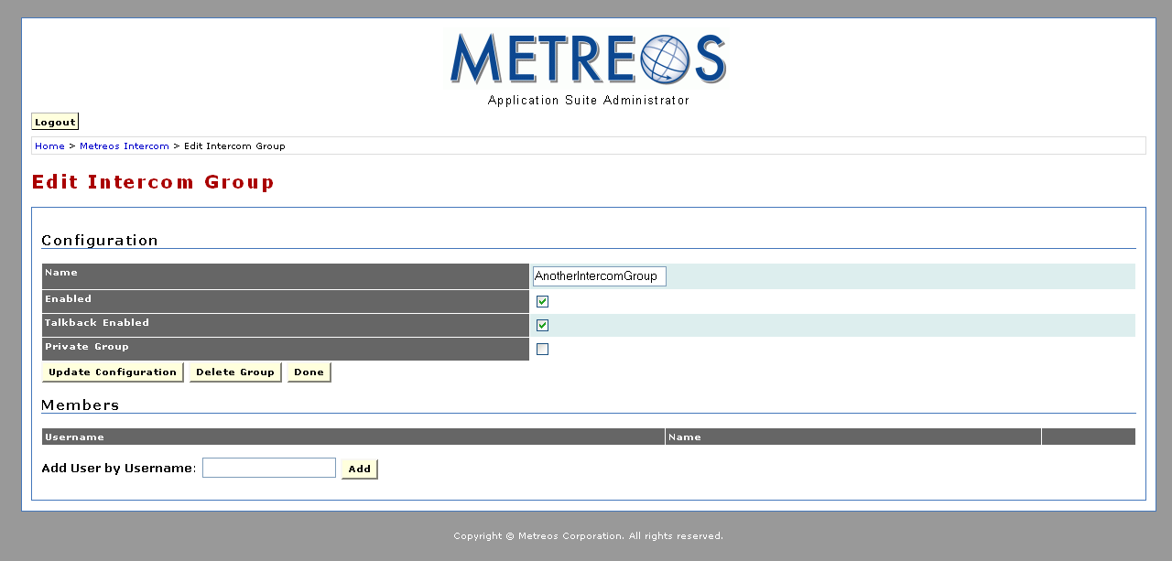
Figure 46: Edit Intercom Group Page
You can now add members to the intercom group. To do so, enter the username in the Username field and click the Add button. Refer to Create User on page 20 for information on account usernames.

Configuring Metreos Intercom
Configure Metreos Intercom using the following procedure:

- Launch the Metreos Management Console and login:

Figure 47: Metreos management Console
- Click the Applications link:

Figure 48: Metreos Management Console Applications Page
- Click the IntercomAndTalkback link:

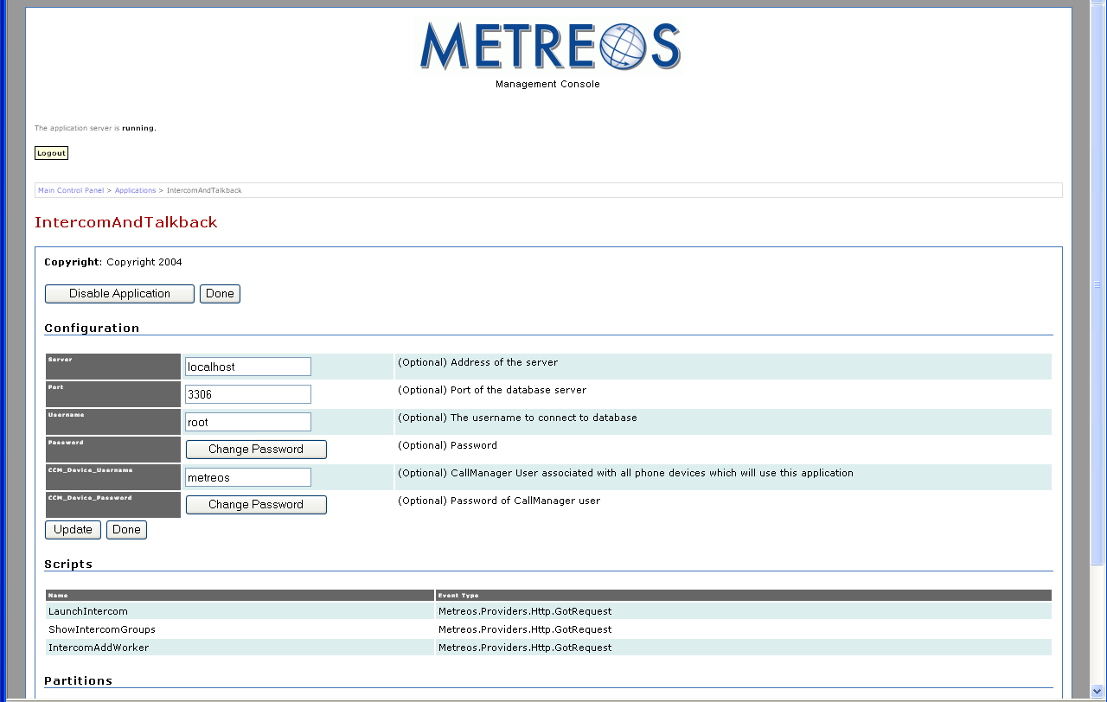
Figure 49: Metreos InterCom Configuration Page
- Fill out the form in accordance with the following list:

  - Server – Enter the application server address.
  - Port – Enter the database port number.
  - Username – The username used to connect to the database.
  - Password – Click the Change Password button to change the password that is used to connect to the database. You will be prompted for your current password and the new password, and you will be prompted to verify the new password. After you have done so, click the Update button.
  - CCM_Device_Username – Enter the Cisco CallManager username associated with phones that use Metreos Intercom.
  - CCM_Device_Password – Click the Change Password button to change the password for the CallManager username. You will be prompted for your current password, the new password, and be prompted to verify the new password. After entering the new password click the Update button.

- Click the Update button on the Intercom configuration page.
- Set the trigger parameter using the procedure in Setting the Trigger Parameter for Metreos Applications on page 34.

Metreos RapidRecord Configuration
Metreos RapidRecord automatically records calls placed to and from a configured group of devices, permitting seamless, hands-off call recording. Recorded calls can be played back either from a Web interface, or directly from the IP phone that placed or received the call.

Configuring Metreos RapidRecord
Metreos RapidRecord is configured using the Metreos Management Console. Use the following procedure:

- Launch the Metreos Management Console and log in:

Figure 50: Metreos Management Console
- Click the Applications link

Figure 51: Metreos Management Console Applications Page
- Click the RapidRecord link:

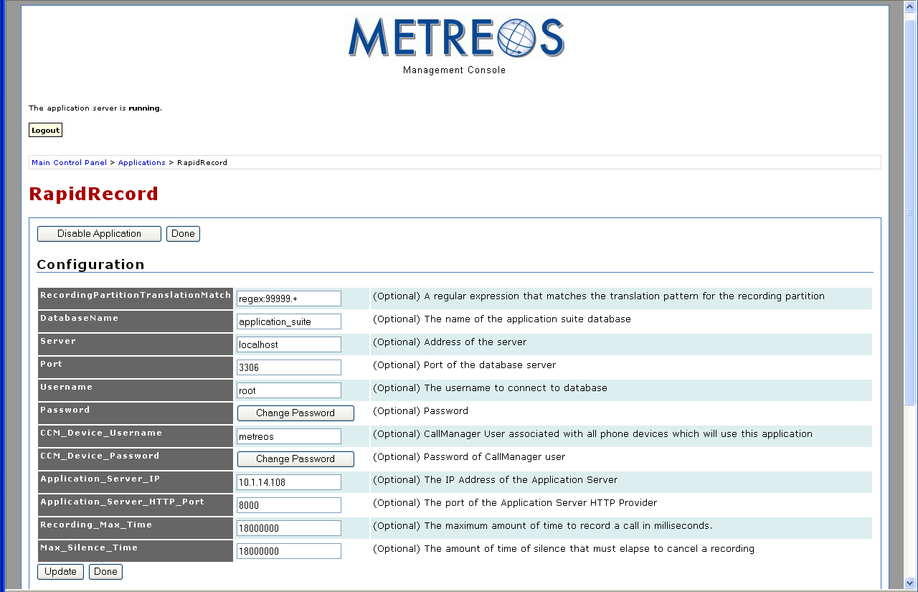
Figure 52: RapidRecord Configuration Page
- Fill out the form in accordance with the following list:

  - RecordingPartitionTranslationMatch – Enter regex:99999.+

The RecordingPartitionTranslationMatch specifies instructions used by RapidRecord to remove leading digits added to directory numbers of calls to be recorded.

To enable use of RapidRecord, Cisco CallManager is configured to modify the directory number of each call made to a recorded device. CallManager adds five nines (99999) to the beginning of the directory number for all such calls.

As described in Table 1: Application Triggering Event Parameters on page 38, the RapidRecord trigger parameter should be set to regex:99999.+. regex:99999.+ is a regular expression, interpreted by RapidRecord as any number preceded by 99999. Because directory numbers of calls to recorded devices are preceded by five nines, each such call triggers RapidRecord.

- RapidRecord uses the value of the RecordingPartitionTranslationMatch parameter (regex:99999.+) to remove leading nines from the dialed number, leaving the original, fully-qualified directory number.
  - Database Name – Enter the name of the Metreos Application Suite database.
  - Server – Enter the application server address.
  - Port – Enter the database port number.
  - Username – Enter the username used to connect to the database.
  - Password – Click the Change Password button to change the password used to connect to the database. You will be prompted for your current password and the new password, and you will be prompted to verify the new password. After you have done so, click the Update button.
  - CCM_Device_Username – Enter the Cisco CallManager username associated with phones that use Metreos RapidRecord.
  - CCM_Device_Password – Click the Change Password button to change the password for the CallManager username. You will be prompted for your current password, the new password, and be prompted to verify the new password. After entering the new password click the Update button.
  - AppServerIP – Enter the IP address of the application server.
  - Application_Server_HTTP_Port – Enter the application server port number.
  - Recording_Max_Time – Enter the maximum recording time in milliseconds.
  - Max_Silence_Time – Enter the maximum interval in milliseconds a call can remain silent before recording is cancelled.

- Click the Update button on the RapidRecord configuration page.
- Set the trigger parameter using the procedure in Setting the Trigger Parameter for Metreos Applications on page 34.

Metreos ScheduledConference Configuration
Metreos ScheduledConference is a Web-scheduled dial-in and dial-out conferencing system. Conferences can be scheduled from an easy-to-use Web interface, eliminating any need for operator or administrative assistance. Features include the adding of conference parties, party mute and unmute, and removal of participants from conference.

Metreos ScheduledConference is configured using the Metreos Management Console. Use the following procedure:

- Launch the Metreos Management Console and log in:

Figure 53: Metreos management Console

- Click the Applications link

Figure 54: Metreos Management Console Applications Page

- Click the ScheduledConference link:

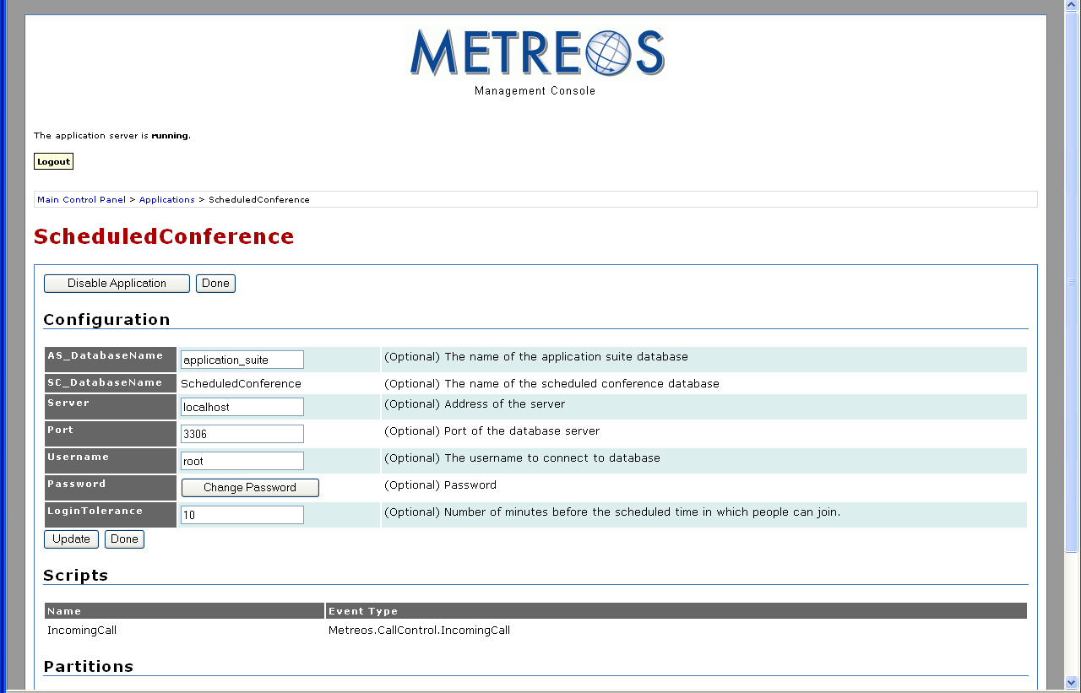
Figure 55: Metreos ScheduledConference Configuration Page
- Fill out the form in accordance with the following list:

  - AS_DatabaseName – Enter the name of the Metreos Application Suite database
  - SC_DatabaseName – Enter the name of the ScheduledConference database
- Server – Enter the application server address.
  - Username – Enter the username used to connect to the database.
  - Password – Click the Change Password button to change the password used to connect to the database. You will be prompted for your current password and the new password, and you will be prompted to verify the new password. After you have done so, click the Update button.
  - LoginTolerance – The length of time in minutes prior to the conference that participants can join the conference.

- Click the Update button on the ScheduledConference configuration page.
- Set the trigger parameter using the procedure in Setting the Trigger Parameter for Metreos Applications on page 34.

Metreos VoiceTunnel Configuration
Metreos VoiceTunnel allows a remote user to connect to any enterprise IP communications system and place calls as if they were local to the system. With Metreos VoiceTunnel you can

- Place all calls locally, avoiding international and long-distance toll charges
- Authenticate call usage and apply a broad range of policies to the billing and accounting of communications costs
- Manage, monitor, and report on the use of the communications system

Use the following procedure to configure Metreos VoiceTunnel:

- Launch the Metreos Management Console and login:

Figure 56: Metreos management Console
- Click the Applications link:

Figure 57: Metreos Management Console Applications Page
- Click the VoiceTunnel link:

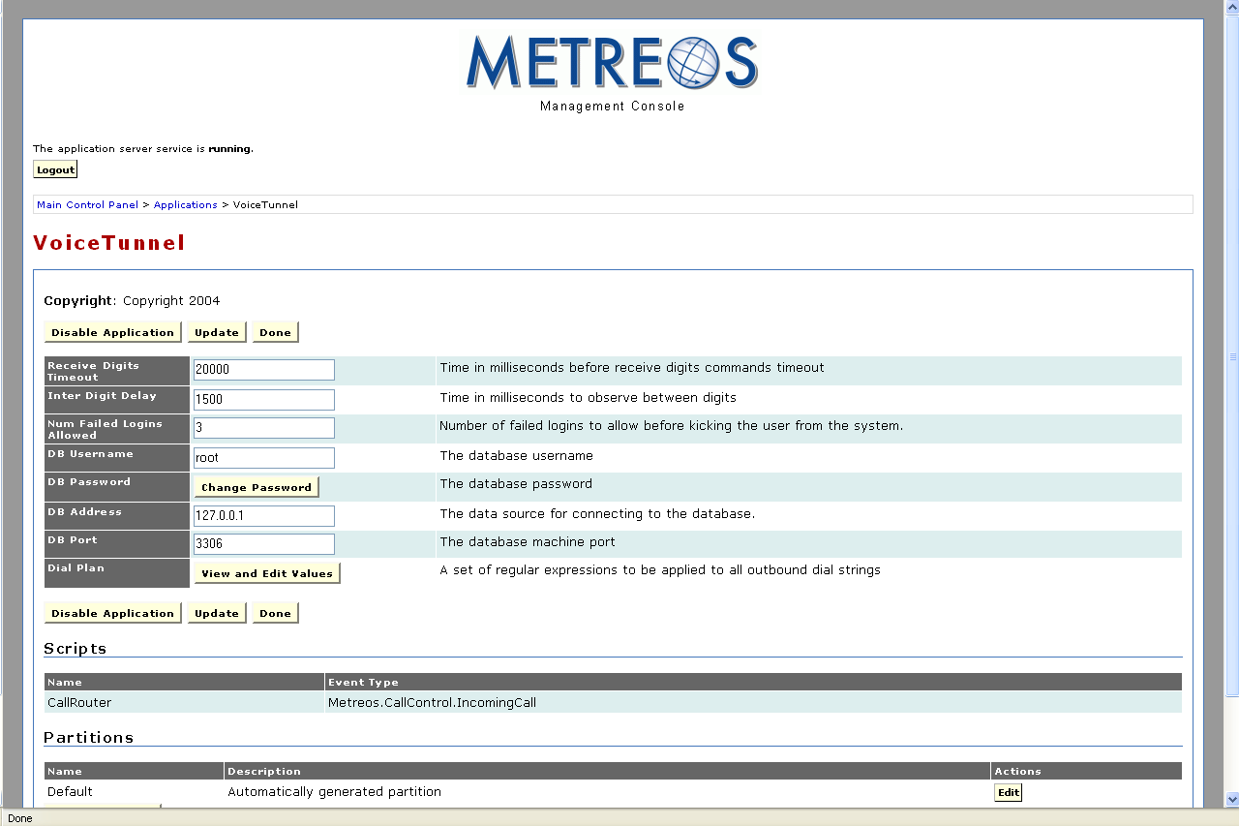
Figure 58: Metreos VoiceTunnel Configuration Page
- Fill out the form in accordance with the following list:

- Receive Digits Timeout – Enter the maximum interval in milliseconds the system will wait for users to dial a number before timing out.
- Inter Digit Delay – VoiceTunnel monitors the amount of time from the entry of one digit to the next in the number a user is calling. Enter the maximum time in milliseconds that may occur between any two dialed digits. If the specified time is exceeded, VoiceTunnel will not recognize the second digit as part of the digit sequence.
- Num Failed Logins Allowed – Enter the number of failed login attempts by a user before that user is prevented from logging in without administrative action.
- DB Username –Enter the username used to connect to the database.
- Password – Click the Change Password button to change the password used to connect to the database. You will be prompted for your current password and the new password, and you will be prompted to verify the new password. After entering the new password click the Update button.
- DB Address – Enter the database IP address
- DB Port – Enter the database port number
- Dial Plan – The purpose of this parameter is to properly identify internal calls. When a call is forwarded to your phone, your phone displays the incoming call number. The incoming call number is a fully qualified directory number if the call is external. Internal calls, however, typically do not require dialing the full number.

A common practice, for example, is to configure the internal dial plan to allow users to dial only the last four digits of the outside line associated with another user in the system. Another common practice for large systems is to allow users to dial a 5 digit number, in which the first digit signifies a physical location and the last 4 digits are used to match the user being called. The CallerID Translations parameter is used to construct a fully qualified directory number for internal calls so the full number can be displayed when the call is forwarded.

The Dial Plan parameter uses a key/value pair to construct the fully qualified directory number. A regular expression is used to determine whether the call is internal and—if so—the regular expression adds an area code and prefix to the internal number. Refer to http://msdn.microsoft.com/library/default.asp?url=/library/en-us/cpgenref/html/cpconRegularExpressionsLanguageElements.asp for more information about regular expressions.

- If the internal dial plan specifies the last four digits plus a leading number representing a physical location, use the following regular expression:

Key ^[0-9\*#](?<internal>[0-9\*#]{4})$ Value xxxyyy${internal}

The first expression in brackets ( [ ] )causes deletion of the initial digit, isolating the last four digits in preparation for constructing the fully qualified directory number.

The 4 in curly braces at the end of the Key field is used to identify incoming calls with four digit numbers. If your facility uses a different number of digits for internal calling, you can vary this number to match the number of digits used for your internal calls

The characters in the Value field represent the area code and prefix for your facility.

- If the internal dial-plan specifies the last four digits of the directory number, use the following regular expression:

Key ^(?<internal>[0-9\*#]{4})$ Value xxxyyy${internal}

The 4 in curly braces at the end of the Key field is used to identify incoming calls with four digit numbers. If your facility uses a different number of digits for internal calling, you can vary this number to match the number of digits used for your internal calls. The characters in the Value field represent the area code and prefix for your facility.

- If the internal dial plan is different than other the two dial plans described in this section, refer to http://msdn.microsoft.com/library/default.asp?url=/library/en-us/cpgenref/html/cpconRegularExpressionsLanguageElements.asp Use the information on that Web site to construct a regular expression for your system.

- Click the Update button on the VoiceTunnel configuration page.
- Set the trigger parameter using the procedure in Setting the Trigger Parameter for Metreos Applications on page 34.

Appendix A: Cisco CallManager Configuration
Cisco CallManager must be properly configured to work with the Metreos Application Suite. This appendix provides the information and procedures necessary for the proper CallManager configuration.

Most of the Metreos Application Suite applications can use either the H.323 or JTAPI protocol to perform call control, but RapidRecord cannot be used with JTAPI.

ActiveRelay also cannot use JTAPI to watch for the incoming call that triggers the application, but it can use JTAPI to place its outbound calls. This Appendix outlines the Metreos Application Suite-specific CallManager configuration required by the H.323 and JTAPI protocols.

Common Procedures
Many of the setup procedures are unique for each protocol. Some procedures, however, are common to both. This section describes the configuration procedures common to H.323 and JTAPI.

Global Metreos User Setup
From the CallManager Administration Web page, go to User → Add a new user. Create a new user with a user ID of metreos, and a password of metreos. Check the Enable calling party number modification box. Every device to be used with the Application Suite must be associated with the metreos user account to run most applications in the Metreos Application Suite.

Partitions
The following three Partitions are required:

- RecordedDevices partition – Lines that will be used with RapidRecord must reside in the RecordedDevices partition.
- Unrestricted partition – Lines that will not be used with RapidRecord must be placed in the Unrestricted partition.
- ApplicationServer partition – Route patterns designed to intercept all calls must reside in the ApplicationServer partition. This technique serves to route all incoming calls to the MCE so that the MCE can in turn route them to the appropriate Metreos application as necessary.

Calling Search Spaces
The following three Calling Search Spaces are required:

- Unrestricted CSS – The Calling Search Space used by unrestricted devices. Every phone device in the Unrestricted Partition has the Unrestricted Calling Search Space.
- RecordedDevices CSS – Every phone device in the RecordedDevices Partition has the RecordedDevices Calling Search Space.
- ApplicationServer CSS: The Application Server Calling Search Space. The ApplicationServer CSS is used by the Application Runtime Environment for the outbound calls that it must place.

Calling Search Space Setup
Configure the three Calling Search Spaces listed in the previous section Calling Search Spaces to contain the following Partitions:

- Unrestricted CSS:
  - Unrestricted Partition
  - RecordedDevices Partition
- RecordedDevices CSS:
  - ApplicationServer Partition
- ApplicationServer CSS:
  - RecordedDevices Partition
  - Unrestricted Partition

When a line that uses the Unrestricted CSS makes a call, CallManager will first search the Unrestricted Partition for a match. If it does not find a suitable match, the CallManager will search the RecordedDevices Partition.

When a line that uses the RecordedDevices CSS places a call, CallManager will search only the ApplicationServer Partition. That Partition should contain a route pattern to intercept all calls as described in Route Patterns for Recording section on page 77. CallManager then routes that call through the Metreos Application Runtime Environment.

The ApplicationServer CSS is used by application server. When the application server places a call, it will first look for the destination number in the RecordedDevices Partition.

Adding Cisco IP Phone Devices
When configuring phone devices for use with the Metreos Application Suite, be aware of the following:

- Ensure the device is associated with the metreos user. If the user does not need ActiveRelay or RapidRecord, associate each line on the device with the Unrestricted CSS, and place it in the Unrestricted Partition.
- To use Metreos ActiveRelay
  - Each user must have two lines residing in the Unrestricted Partition and using the Unrestricted CSS
  - the primary line must rollover to a secondary line
To meet these two requirements set the Forward Busy field on the first line to the number of the secondary line.
- To use Metreos RapidRecord, each line that is to be recorded must be placed in the RecordedDevices Partition, and must use the RecordedDevices CSS. Calls can be forwarded to other lines as necessary.
- After configuring the lines for the device, the device must be reset.
- A user can not be configured to use both Metreos RapidRecord and Metreos ActiveRelay at the same time.

Cisco IP Phone Services Setup
Two applications in the Metreos Application Suite provide Cisco IP Phone Service functionality:

- Metreos ActiveRelay
- Metreos Intercom

In order for a phone to access these services, the phone must be subscribed to the corresponding service using CallManager Administrator.

This section presents the procedure for configuring IP phone services using the default triggering criteria for Metreos ActiveRelay and Metreos Intercom.

The Application Server, by default, listens for HTTP requests on port 8000. Proceed to
Feature → Cisco IP Phone Services page in CallManager Administrator. For each of the following services, click Add a New IP Phone Service:

  - ActiveRelay IP service:
- Specify ActiveRelay for the Service Name field
- Specify http://MCE_IPAddress:8000/ActiveRelay?device=#DEVICENAME# for the Service URL field
- Click Insert
- Intercom IP service:
- Specify Intercom for the Service Name field
- Specify http://MCE_IPAddress:8000/ShowIntercomGroups?device=#DEVICENAME# for the Service URL field.
- Click Insert.

Note: Each device that uses Metreos ActiveRelay must be subscribed to the ActiveRelay service and each device that uses Metreos Intercom must be subscribed to the Intercom service.

The #DEVICENAME# token is recognized by the Cisco IP phone, and then replaced with the Device Name of the phone, before the request is sent out to the application server.

Creating CallManager Clusters
You must set up a CallManager cluster using the Metreos Management Console. Refer to the Creating CTI Telephony Devices section of the Metreos Communications Environment Management Console User Guide for details.

H.323 configuration
The Application Server is set up as both a gateway and a H.323 device in CallManager. The application server must have two IP addresses associated with its network adapter:

- An IP address for a H.323 gateway configuration
- An IP address for H.323 phone devices

Refer to the Network Configuration of the Metreos Communications Environment Management Console User Guide for more information on network settings configuration.

H.323 Gateway Setup
To create a H.323 Gateway:

- In CallManager Administrator, click Device → Gateway. Select Add a New Gateway.
- Select H.323 Gateway for the Gateway type field
- Click the Next button.
- Set the Device Name field to the first IP address of the application server network adapter you configured earlier.
- Set the Device Pool to Default.
- Set the Calling Search Space field to ApplicationServer.
- Click the Insert button.
- Configure a MCE H.323 gateway using the Metreos Management Console. Refer to the Creating H.323 Call Route Groups and Gateways section of the Metreos Communications Environment Management Console User Guide for details.

H.323 Device Setup
To create a H.323 phone device:

- In CallManager Administrator, click on Device → Phone.
- Select Add a New Phone.
- Select H.323 Client for the Phone type field
- Click the Next button.
- Set the Device Name to the second IP address of the appliance.
- Set the Device Pool to Default.
- Click the Insert button.

The H.323 Phone Device is required by two applications: Metreos RapidRecord and Metreos ActiveRelay.

Metreos RapidRecord requires that you add a new line on the H.323 device for each line in the RecordedDevices Partition a corresponding line must be added to the H.323 device. Configure each line that you add to the H.323 device in accordance with the following requirements:

- Configure the line to be in the Unrestricted Partition, and to have the Unrestricted CSS.
- Set the Forward All → Destination field to the same number as the Directory Number field for this line.
- For every recorded line that you configure for H.323 devices, the
Forward All → Calling Search Space field should be set to RecordedDevices.

Metreos ActiveRelay requires that you add a new line on the H.323 phone device for every ActiveRelay-enabled primary device. This line number should be the same as the primary line number of the primary device for the user in question. The primary device and the primary line number are both listed on the edit account page for the user in Main Page → Account Management → edit user. Use the following procedure in the CallManager Administrator to add the required lines on the H.323 phone device:

- Configure each line to be in the Unrestricted Partition.
- Configure each line to have an Unrestricted CSS.
- Set the Forward Busy field to the directory number of the second line for the device in question.
- Reset the device.
- Add the line number to the values of the to trigger parameter in the ActiveRelay Default partition. Refer to Setting the Trigger Parameter for Metreos Applications on page 34 for details.

Note: The use of the Metreos ActiveRelay and Metreos RapidRecord applications on the same line is not supported.

Route Patterns for Recording
Route patterns allow you to intercept calls using symbols that represent a dial pattern. The route patterns described in this section must route to the application server gateway you previously created. Depending on your local configuration, you might be required to add two or more route patterns to the ApplicationServer partition.

The application server has its own unique CSS, so that all calls placed by the Application Runtime will be routed by its CSS. All calls made from a recorded device, for example, will have the same CSS as the application server. These calls have the same CSS as the application server, because RapidRecord must intercept them and connect them to the intended party.

The following route patterns are supported:

- @ – Intercepts all call patterns for a given Numbering Plan, such as the North American Numbering plan. Depending on the dial plan for your facility you might want to change this pattern to 9.@ to match your local and long distance prefix digit calling pattern. The Prefix Digits (Outgoing Calls) field in the Called Party Transformations section should contain the value 99999, a requirement of Metreos RapidRecord. The pattern should reside in the ApplicationServer partition.
- 1XXX – Intercepts all calls containing four digits, for which the first digit is 1. This pattern is required for internal calls. Some phone systems support internal calling with multiple dialing patterns. A system might, for example, require four digits for some numbers or devices and five digits for others.

In such cases a route pattern of this form must be created for each dialing requirement. In our example of a four-digit and five-digit dialing system a 1XXX route pattern and a 1XXXX route pattern must be created.

You should create a route pattern of this form for all numbers that the recorded user might dial. If, for example, the user has a need to dial 4 digit numbers beginning with 1 and five digit numbers beginning with 2, you must create route patterns that intercept those dialing patterns.

The Prefix Digits (Outgoing Calls) field in the Called Party Transformations section should contain the value 99999, a requirement of Metreos RapidRecord. These patterns should reside in the ApplicationServer partition, and they should point to the previously created gateway.

You must also set the to field of the trigger parameter in the RapidRecord Default partition to regex: 99999.+. Refer to Setting the Trigger Parameter for Metreos Applications on page 34 and on page 59 for details.

Other Route Patterns
The VoiceTunnel, ClickToTalk, and ScheduledConference applications are accessed by dialing directory numbers specific to each application. Use the following procedure to create a route pattern for each of these three applications:

- Create a route pattern containing no wildcard digits, such as 7000, and point it to the IP address of the application server gateway. The route patterns should reside in the Unrestricted partition.
- Enter the route pattern in the to field of the trigger parameter of the Default partition for each application except Metreos ActiveRelay. Refer to Setting the Trigger Parameter for Metreos Applications on page 34 for details.
- Create duplicates of the VoiceTunnel and ScheduledConference patterns, but not that of ClickToTalk. Use the previously described procedure—but place these duplicates in the ApplicationServer partition. Also, set the Prefix Digits (Outgoing Calls) field in the Called Party Transformations section to the value 99999. Doing so allows devices in the RecordedDevices Partition to access these applications.

Note: Metreos ActiveRelay and Intercom do not require route patterns.

JTAPI configuration
To configure JTAPI you must create several CTI Route Points, some of which require multiple lines. The MCE uses these CTI Route Points for two purposes:

- To monitor and control calls coming into a Route Point’s lines
- To place outbound calls

Refer to the Creating CTI Telephony Devices section of the Metreos Communications Environment Management Console User Guide for information on how to configure the MCE to use a CTI Route Point.

Note: Metreos RapidRecord does not support JTAPI. Also, Metreos ActiveRelay cannot use JTAPI to watch for incoming calls, such as triggering call, but it can use JTAPI to place outbound calls.

CTI Route Point Setup
Use the following procedure to set up a CTI route point:

- From the CallManager Administrator page, navigate to Device → CTI Route Point.
- Click the Add a New CTI Route Point link.
- Set the Device Name field to MCE_RT_PT_GEN, or to another name of your choice. You must use this name later when configuring CTI Device Pools for the MCE.
- Set the Device Pool field to Default.
- Click the Insert button to add the route point to CallManager. If CallManager prompts you as to whether you want to add a line to this route point, select either No or Cancel.

The MCE_RT_PT_GEN route point can be used by Metreos VoiceTunnel, Metreos ScheduledConference, and Metreos ClickToTalk. If you plan to use JTAPI with Metreos ActiveRelay to place outbound calls, you must configure an additional route point for this purpose. To add this ActiveRelay-specific route point, follow the procedure presented in the first paragraph of this section—but set the Device Name field to MCE_RT_PT_AR.

Associate the CTI Route Points with the metreos User
The newly-created route points must be associated with the metreos user. Details about the metreos user are provided in the Global Metreos User Setup section of this Appendix. Use the following procedure to associate CTI route points with the user:

- From the CallManager Administrator, navigate to User → Global Directory, and then locate and select the metreos user.
- Follow the Device Association link from the User Configuration page.
- Locate the route point devices that you created earlier.
- Check the checkbox next to each of the devices.
- Click the Update Selected button.

Adding lines to the CTI Route Points
Users access Metreos VoiceTunnel, Metreos ClickToTalk, and Metreos ScheduledConference through unique directory numbers. You must add a line to the MCE_RT_PT_GEN route point for each of these applications. Use the following procedure:

- Add a new line to the MCE_RT_PT_GEN route point.
- Set the Directory Number field to app_directory_number.
- Enter app_directory_number in the to field of the trigger parameter of the Default partitions for each application. Refer to Setting the Trigger Parameter for Metreos Applications on page 34 for details.
- Set the Partition field to Unrestricted.
- Set the Calling Search Space field to ApplicationServer.
- Click the Add button.

If you created the MCE_RT_PT_AR route point for Metreos ActiveRelay, you must add one new line. The directory number you assign to this line will be the CallerId number that is displayed on all outbound calls placed by ActiveRelay. Use the following procedure:

- Add a new line to the MCE_RT_PT_AR route point.
- Set the Directory Number field to your_directory_number
- Set the Partition field to Unrestricted.
- Set the Calling Search Space field to ApplicationServer.
- Click the Add button

The presence of any individual application in your deployment is dependent on the license in effect.
Refer to on page 59 for more information about RapidRecord trigger parameters.
Refer to http://msdn.microsoft.com/library/default.asp?url=/library/en-us/cpgenref/html/cpconRegularExpressionsLanguageElements.asp for information about regular expressions.

